GOVERNOR’S SECRETARIAT
ARUNACHAL PRADESH
ITANAGAR

Press Communiqué
Dated Feb 1st, 2025

Governor launches Arunachal Tourism promotional calendar
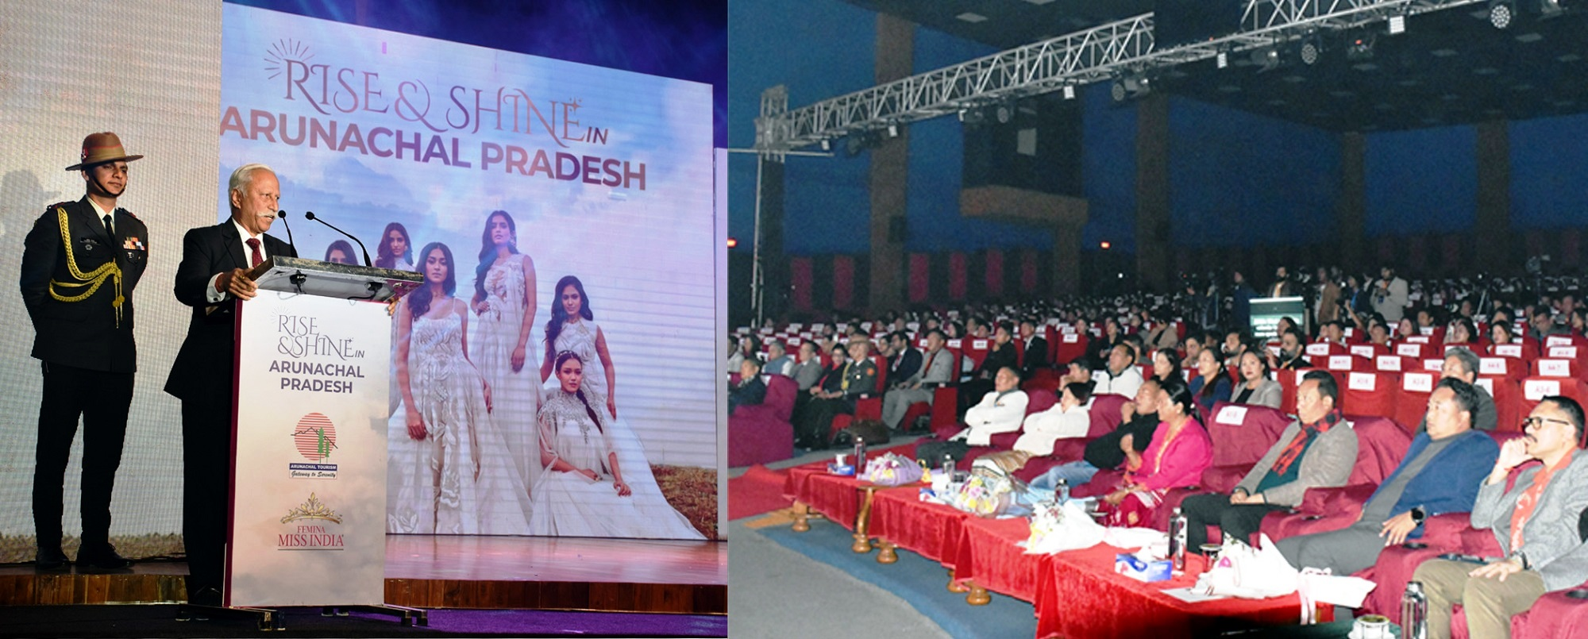

- Arunachal Pradesh has all the ingredients to become a world-class tourist destination: Governor
- Tourism is one of the wheels of development and progress of Arunachal Pradesh: Governor
- With collective efforts from the government, local communities, and tourism agencies, we can unlock its true potential while preserving its unique heritage: Governor

The Governor of Arunachal Pradesh Lt. General KT Parnaik, PVSM, UYSM, YSM (Retd.) launched the ‘Rise & Shine’ calendar 2025 at Dorjee Khandu Convention Centre, Itanagar on 1st February 2025. The calendar highlights the unparalleled beauty, cultural heritage and tourism potential of Arunachal Pradesh reinforcing the State Government’s commitment to positioning the State as a premier tourism destination.
The Governor said that the event will contribute to promoting Arunachal Pradesh as a world-class tourism destination. He reposed his faith that the tourism and travel initiative would go a long way in reflecting the true cultural diversity of Arunachal Pradesh and harnessing the tourism potential of the State.
The Governor said that Arunachal Pradesh has all the ingredients to become a world-class tourist destination. With collective efforts from the government, local communities, and tourism agencies, we can unlock its true potential while preserving its unique heritage. He appealed to all to work together to showcase Arunachal Pradesh as a must-visit destination and contribute to the sustainable development of tourism in the region.
The Governor commended the Tourism Minister Shri PD Sona, officers and officials of the State Tourism Department and Miss India Organization, Times Group for the joint venture. He said that through the collaboration with Times Group and Miss India Organization, the State will showcase the wonders of the State to the world.
The Governor, who has been emphasizing on harnessing the tourism potential of the State, said that the State Government is committed to addressing the issues related to the sector as tourism is one of the wheels of development and progress of Arunachal Pradesh. He said investments in infrastructure are in the pipeline, streamlining as well as digitizing the permit system, to make travel easier and appealing to visitors. It will promote eco-tourism, adventure tourism, and community-based tourism while benefiting local communities. He stressed on focusing on hospitality to attract tourists.
State Tourism Minister Shri Pasang Dorjee Sona, Secretary Tourism Shri Ranphoa Ngowa and Brand & Operation Head, Miss India organization Ms Natasha Grover also spoke on the occasion.
The event was organized by the State Department of Tourism in collaboration with Miss India Organization, Times Group. A specially curated audio-visual presentation of the State's tourism attractions was premiered, offering an immersive glimpse into the cultural and natural wealth of Arunachal Pradesh. The captivating visuals drew applause from the audience, setting the perfect tone for the evening, followed by a mesmerizing cultural dance performance representing Arunachal Pradesh's rich traditions.
