GOVERNOR’S SECRETARIAT
ARUNACHAL PRADESH
ITANAGAR

Press Communiqué

Dated Feb 17th, 2025

Cabinet Aapke Dwar Held at Ane Nyapin, Kurung Kumey
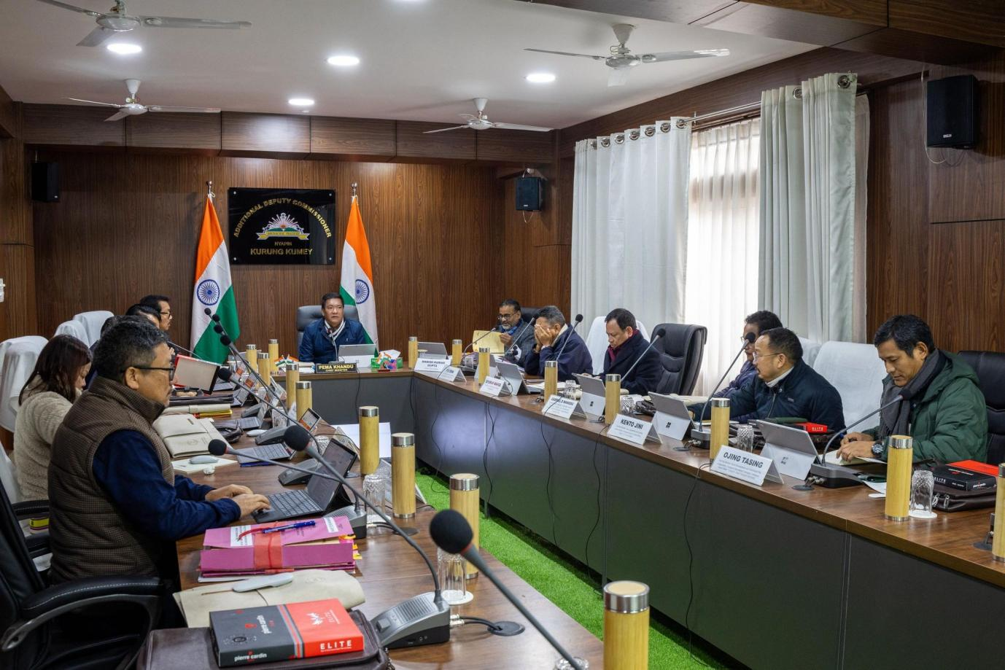
Nyapin, February 17, 2025: The Government of Arunachal Pradesh, under the leadership of Hon’ble Chief Minister Shri Pema Khandu, conducted a historic "Cabinet Aapke Dwar" at Ane Nyapin in Kurung Kumey district today. This initiative marks a significant step towards inclusive and people-centric governance, bringing decision-making closer to the citizens.
Holding a Cabinet meeting in such a remote and small town demonstrates the government’s commitment to ensuring grassroots participation in the state's development process. The Cabinet, convened in the presence of senior ministers and officials, deliberated on key policy matters and took several important decisions aimed at accelerating growth and addressing local challenges.
This initiative underscores the government’s vision of "Taking Governance to the People", ensuring accessibility, transparency, and responsive administration for the welfare of Arunachal Pradesh.
