GOVERNOR’S SECRETARIAT
ARUNACHAL PRADESH
ITANAGAR

Press Communiqué

Dated Feb 17th, 2025

Governor inaugurates drug de-addiction facility
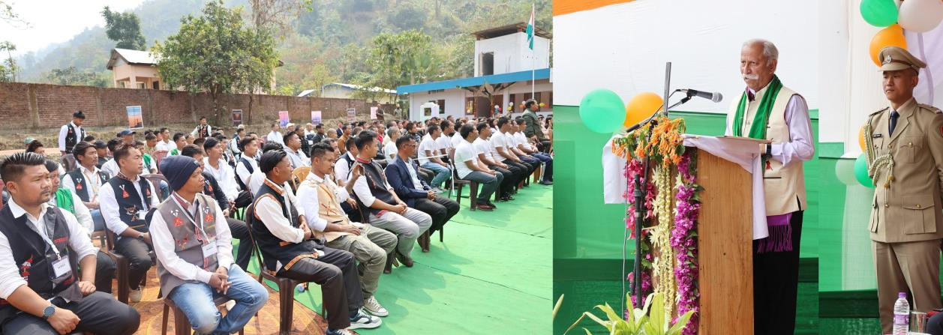
The Governor of Arunachal Pradesh Lt. General KT Parnaik, PVSM, UYSM, YSM (Retd.) inaugurated a counseling hall and isolation room of Charju De-Addiction Center, near Khonsa in Tirap District on 17th February 2025. Care Me Home Welfare Society is running the centre. Care Me Home Welfare Society Chairperson, Smti Sontung Lowang Bangsia and renowned social activist Shri Tai Tagak conducted the Governor around the Centre and briefed about the activities of the NGO.
Speaking on the occasion, the Governor said that helping an individual overcome addiction is no less than an act of God. He commended the efforts of Care Me Home Welfare Society, stating that their work contributes towards ‘Viksit Arunachal’, a healthier, more progressive society.
Expressing deep concern over rising drug addiction among the youth and the threat posed by drug peddlers, the Governor stressed that drug abuse is eroding the fabric of society. He called upon every responsible citizen to take a stand against this growing menace.
The Governor urged Panchayat members, Gaon Burahs, and community elders to play an active role in monitoring, guiding, and mentoring young individuals, ensuring they become responsible and productive members of society. He emphasized that all efforts be made to prevent youth from getting addicted to drugs, by early detection and reformative action.
Addressing young individuals struggling with addiction, the Governor reassured them that they have a future. He encouraged them to believe in themselves, engage in physical activities such as sports, and acquire skills that will help them rebuild their lives. He also assured them of the State Government’s full support in their journey to recovery.
As a symbolic gesture of encouragement, the Governor presented a ‘Team Arunachal’ lapel pin to a reformed youth who shared his personal battle with addiction. He urged him to inspire others by sharing his journey and guiding them toward a healthier, drug-free life.
The event also saw active participation from recovering youth and inmates of the rehabilitation center.
Local MLA Shri Wanglam Sawin and Tirap Deputy Commissioner Shri Techu Aran also spoke on the occasion.
Director General of Police Shri Anand Mohan, Inspector General of Police, TCL, Shri P.N. Khrimey, Superintendent of Police Shri Singjatla Singpho, Government officers and officials and Gaon Burahs and Panchayat members were present on the occasion.
Earlier, arriving at Charju Village, the Governor offered prayer at Charju Rangsom Hum, an Indigenous prayer center, along with the local population for the wellbeing of all.
The Governor of Arunachal Pradesh Lt. General KT Parnaik, PVSM, UYSM, YSM (Retd.) inaugurated a counseling hall and isolation room of Charju De-Addiction Center, near Khonsa in Tirap District on 17th February 2025. Care Me Home Welfare Society is running the centre. Care Me Home Welfare Society Chairperson, Smti Sontung Lowang Bangsia and renowned social activist Shri Tai Tagak conducted the Governor around the Centre and briefed about the activities of the NGO.
Speaking on the occasion, the Governor said that helping an individual overcome addiction is no less than an act of God. He commended the efforts of Care Me Home Welfare Society, stating that their work contributes towards ‘Viksit Arunachal’, a healthier, more progressive society.
Expressing deep concern over rising drug addiction among the youth and the threat posed by drug peddlers, the Governor stressed that drug abuse is eroding the fabric of society. He called upon every responsible citizen to take a stand against this growing menace.
The Governor urged Panchayat members, Gaon Burahs, and community elders to play an active role in monitoring, guiding, and mentoring young individuals, ensuring they become responsible and productive members of society. He emphasized that all efforts be made to prevent youth from getting addicted to drugs, by early detection and reformative action.
Addressing young individuals struggling with addiction, the Governor reassured them that they have a future. He encouraged them to believe in themselves, engage in physical activities such as sports, and acquire skills that will help them rebuild their lives. He also assured them of the State Government’s full support in their journey to recovery.
As a symbolic gesture of encouragement, the Governor presented a ‘Team Arunachal’ lapel pin to a reformed youth who shared his personal battle with addiction. He urged him to inspire others by sharing his journey and guiding them toward a healthier, drug-free life.
The event also saw active participation from recovering youth and inmates of the rehabilitation center.
Local MLA Shri Wanglam Sawin and Tirap Deputy Commissioner Shri Techu Aran also spoke on the occasion.
Director General of Police Shri Anand Mohan, Inspector General of Police, TCL, Shri P.N. Khrimey, Superintendent of Police Shri Singjatla Singpho, Government officers and officials and Gaon Burahs and Panchayat members were present on the occasion.
Earlier, arriving at Charju Village, the Governor offered prayer at Charju Rangsom Hum, an Indigenous prayer center, along with the local population for the wellbeing of all.
