GOVERNOR’S SECRETARIAT
ARUNACHAL PRADESH
ITANAGAR

Press Communiqué

Dated Feb 16th, 2025

Governor reviews developmental works of Lohit District
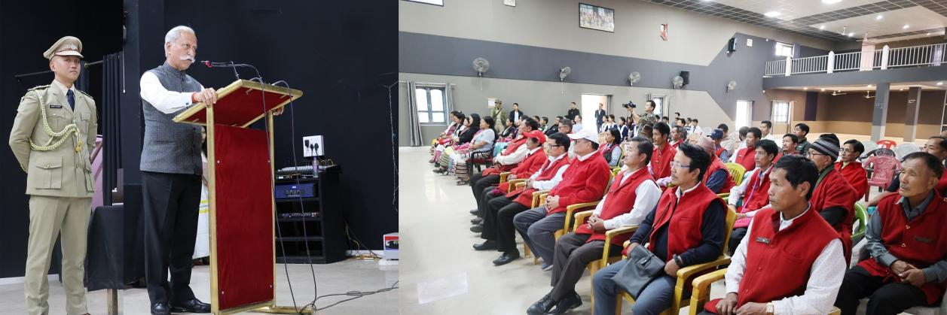
The Governor of Arunachal Pradesh Lt. General KT Parnaik, PVSM, UYSM, YSM (Retd.) reviewed the Central and State Government-sponsored programmes, projects and schemes of Lohit District at Tezu on 16th February 2025. The Governor, who is on a two-day tour of the district, was briefed about the progress and challenges of the flagship programmes.
The Governor emphasized the need for automation of all data related to Yojanas being implemented in the district to augment analysis, monitoring, and management. He also urged officials to think out-of-box, explore proactive measures, and actively engage with the public.
Highlighting the potential and capability of the people of Arunachal Pradesh, the Governor stressed that government officials must support them in realizing their aspirations. He underscored the importance of transferring technical advancements from Krishi Kendras, scientific laboratories, and research centers to the fields, ensuring they benefit rural communities.
Encouraging officials to connect with the agrarian community and allied sector farmers, he noted that the State’s farmers and entrepreneurs in the sector have the potential to transform the farming sector but need proper motivation and guidance.
The Governor emphasized that the progress of the rural community, especially the youth, is vital for the development of Arunachal Pradesh. He stated that when rural areas become ‘Viksit,’ the State will achieve ‘Viksit Arunachal,’ contributing to the collective vision of a ‘Viksit Bharat.’
Lohit Deputy Commissioner, Shri Kesang Ngurup Damo highlighted the progress, accomplishments, initiatives and priority areas for development of the district.
Dr. Mahesh Chai, Director General of Police, Shri Anand Mohan, Superintendent of Police, Shri Thutan Jamba and Heads of Department participated in the review meeting.
Earlier, the Governor met the Gaon Burahs, Panchayat representatives and the public. During his interaction, emphasizing the crucial role of education in shaping the future of the State, the Governor urged village elders to ensure that every child completes their education without dropping out. Citing the National Education Policy (NEP) 2020, he highlighted its potential to equip students with essential skills, making them job-ready, particularly in sectors such as hydropower and infrastructure development.
Expressing concern over the rising menace of drug abuse among the youth, the Governor called for collective efforts to address the issue and safeguard the younger generation from its harmful impact.
Stressing the need to strengthen the healthcare sector, he underscored the importance of cleanliness, hygiene, and sanitation awareness in fostering a healthier society. As a proactive measure, he suggested the formation of a Hygiene and Sanitation Committee led by women, who could be trained and incentivized to promote better hygiene practices within their communities.
The Governor reaffirmed the government's commitment to education, skill development, and public health, emphasizing that these initiatives are essential for the State’s progress and prosperity.
Local MLA, Dr. Mahesh Chai, Director General of Police, Shri Anand Mohan, Superintendent of Police, Shri Thutan Jamba and Heads of Department were present in the meeting.
The Governor started his district tour with a visit to the famed religious site, Parasuram Kund, near Wakro, in Lohit District. He reviewed the site which is being developed under PRASAD (Pilgrimage Rejuvenation and Spiritual Augmentation Drive) scheme of the Ministry of Tourism, Government of India.
The Governor, who participated in the Kumbh Mela recently at the invitation of the Uttar Pradesh Government, suggested various measures to make it more convenient for the pilgrims and devotees and appealing to the visitors. He also advised for holistic development of the area, linking economic empowerment of the local communities
