GOVERNOR’S SECRETARIAT
ARUNACHAL PRADESH
ITANAGAR

Press Communiqué

Dated Feb 16th, 2025

Governor adopts to TB patients of Lohit District
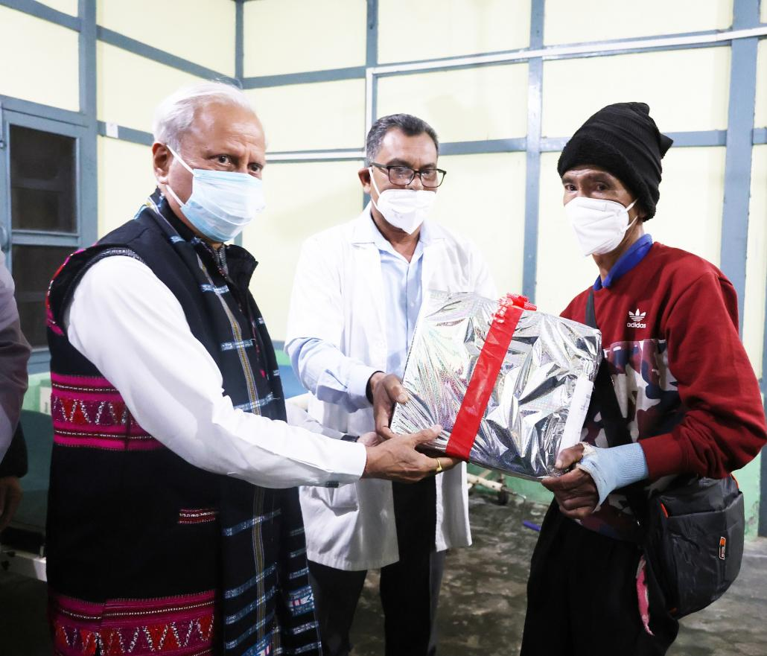

The Governor of Arunachal Pradesh, Lt. General KT Parnaik, PVSM, UYSM, YSM (Retd.), visited the Zonal General Hospital, Tezu, Lohit District on 16th February 2025. During his visit, he visited different wards of the Hospital and interacted with medical officers and nursing staffs.
Continuing his ongoing commitment to eradicate tuberculosis in the State, and in his role as a Nikshay Mitra, the Governor adopted two TB patients from Lohit District. He presented food baskets to the adopted patients. As a Nikshay Mitra, the Governor will be providing the TB patients with nutritional, diagnostic, and vocational support for six months.
The Governor appealed to the people to adopt TB patients and join hands to eradicate Tuberculosis from Arunachal Pradesh. He reminded them of Prime Minister Narendra Modi’s goal to eliminate tuberculosis from India by 2025, ahead of the global TB-related Sustainable Development Goals (SDGs) target of 2030.
The Governor encouraged health officials to promote healthy lifestyles, raise health awareness, and leverage technology for better analysis and planning. He also praised the dedication of doctors, nurses, and paramedics in driving social reforms within the health centers, embodying the ethos of “care and share.”
District Tuberculosis Officer Dr. Uttam Kumar Nath briefed the Governor on TB and health issues in the district.
Local MLA, Dr. Mahesh Chai, Director General of Police, Shri Anand Mohan, Superintendent of Police, Lohit Deputy Commissioner, Shri Kesang Norbu Damo, Shri Thutan Jamba, District Reproductive and Child Health Officer, Dr. Linya Lollen, District Hospital Medical Superintendent Dr. T. Kena and officials of Health Department were present during the visit.
