GOVERNOR’S SECRETARIAT
ARUNACHAL PRADESH
ITANAGAR

Press Communiqué

Dated Feb 16th, 2025

Gensi Music Festival 2.0 Inaugurated with Grandeur
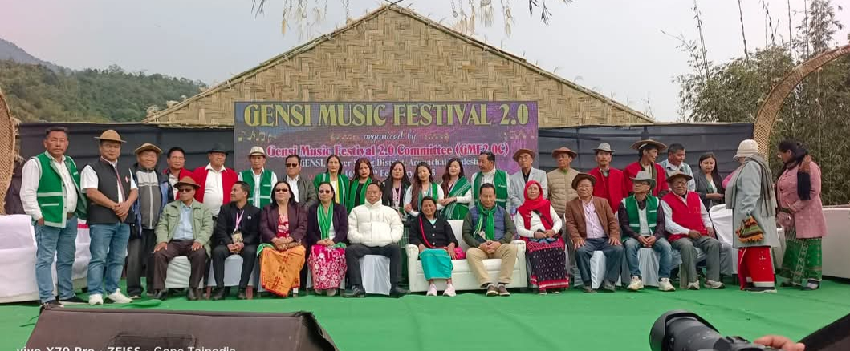

Gensi, February 16: The Gensi Music Festival 2.0 commenced today with great enthusiasm, celebrating the rich cultural heritage of the Galo tribe while promoting tourism in the region. The festival was graced by Smti Nyabi Jini Drichi, Hon’ble MLA of Leparada, as the Chief Guest; Shri Topin Ete, Hon’ble MLA of 30th Aalo West, as the Guest of Honour; and Shri Kardo Nyigyor, Hon’ble Deputy Speaker of Arunachal Pradesh Legislative Assembly, as the Chief Patron.
The event, held in the picturesque town of Gensi, aims to showcase the area’s cultural vibrancy and potential as a tourist destination. In her address, Chief Guest Smti Nyabi Jini Drichi expressed her heartfelt gratitude to the organizing team, led by Chairman Shri Gope Taipodia and Secretary Shri Nyukar Taipodia, for their tireless efforts in organizing the festival.

She also extended her best wishes to the talented artists who traveled from across the region to participate in the event. "Your passion and dedication are truly inspiring, and I wish you continued success in your artistic journey," she remarked.
Guest of Honour Shri Topin Ete also addressed the gathering, emphasizing the importance of such events in preserving cultural heritage and promoting tourism.
The three-day festival will continue with various cultural performances, musical events, and local exhibitions, promising an unforgettable experience for visitors while highlighting Gensi as a promising tourist destination.
