GOVERNOR’S SECRETARIAT
ARUNACHAL PRADESH
ITANAGAR

Press Communiqué

Dated Feb 16th, 2025

Kush Mini Hydel Station Commissioned in Kurung Kumey
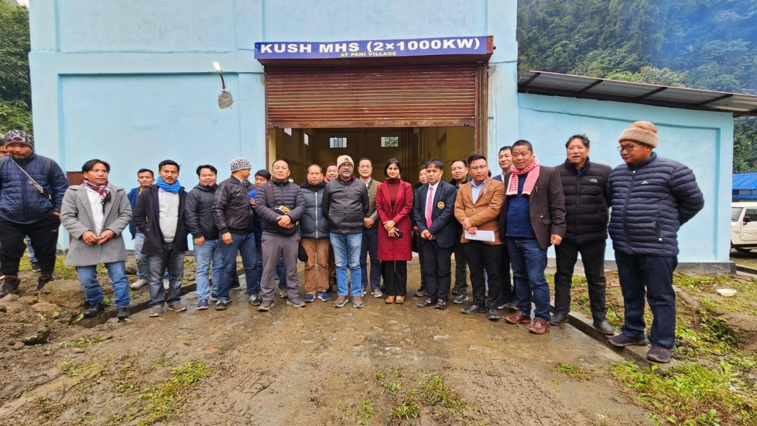

Sangram, Feb 16: The Arunachal Pradesh Chief Secretary, Manish Gupta, on Sunday commissioned the 2X1000KW Kush Mini Hydel Station (MHS) at Pani Village in Kurung Kumey district. The event was attended by top officials from the Hydropower Development (HPD) department, district administration, local leaders, and members of the public. Addressing the media, Chief Secretary Gupta highlighted that the project, proposed decades ago, faced delays due to litigation. However, under the leadership of Chief Minister Pema Khandu, the government prioritized the development of hydropower projects, including micro, mini, and mega initiatives, for public benefit. The Kush MHS was taken up under this initiative, and all infrastructure and technical work have been completed, except for the road connecting it to the Trans-Arunachal Highway (TAH). A successful trial run of the project was conducted, and further testing will continue to ensure proper synchronization of machinery and equipment. Manpower and operators have been deployed to monitor any eventualities. The HPD officers briefed on the benefits of the project for the public and its revenue contribution to the state exchequer. Chief Secretary Gupta noted that several micro and mini hydel projects in Nyapin and Koloriang Assembly constituencies have the potential to meet the district's power supply needs, making it self-sufficient. He added that the damaged hydel project near Koloriang, affected by road construction, would be taken up with the concerned department for revival. HPD Chief Engineer (West Zone) Jumar Kamdak expressed satisfaction over the completion of the long-pending project, despite previous setbacks. He emphasized the role of Chief Minister Pema Khandu in reviving the project even after delays due to litigation and the COVID-19 pandemic. The trial run will continue for a few weeks to examine technical and mechanical aspects. Kamdak further informed that the project, situated between Sangram and Koloriang, initially lacked road connectivity, making its construction challenging. However, with the active support of the local population, the project was completed. The department is also considering the payment of liabilities to locals. A 2 km road connecting the project, along with staff quarters and other facilities, has been proposed. Among the seven hydropower projects in Kurung Kumey, the Kush MHS, with a capacity of 2 MW, is the largest. If all projects become operational, they will fulfill the district's power requirements. The commissioning ceremony was attended by Kurung Kumey Deputy Commissioner, HPD Superintending Engineer (Ziro Circle), senior HPD officers, and officials from various departments. Later, the DC inspected other ongoing projects and visited the hospital, DC office, and other infrastructure in Koloriang.

