GOVERNOR’S SECRETARIAT
ARUNACHAL PRADESH
ITANAGAR

Press Communiqué

Dated Feb 15th, 2025

Deputy Chief Minister Chowna Mein Attends 55th Central Tamlã-Dü Festival in Khoraliang (Tezu) as Chief Guest
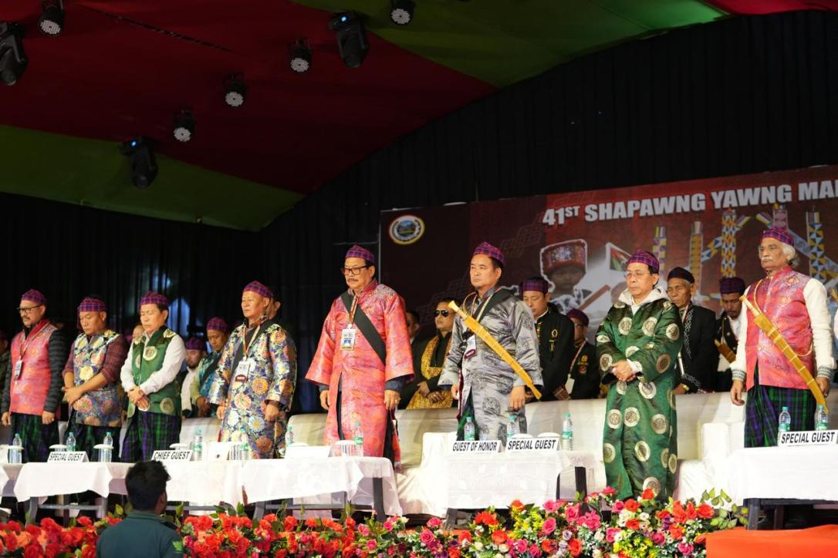
Tezu, February 15: The 55th Central Tamlã-Dü Festival was celebrated with great enthusiasm in Khoraliang village, Tezu, bringing together the Mishmi community and dignitaries under the theme ‘Connecting to Brotherhood’. The festival, a vibrant display of Mishmi community of Lohit District’s rich cultural heritage, focused on fostering unity and communal harmony among communities.
Deputy Chief Minister Chowna Mein attended the festival as the Chief Guest, reaffirming his commitment to preserving and promoting indigenous traditions while strengthening Arunachal Pradesh’s development vision. In his address, he emphasized the State’s long-term mission for all round development in sectors like education, healthcare, tourism, horticulture, and agriculture, which serve as pillars of Arunachal Pradesh’s progress and self-reliance. He reiterated the government’s commitment to empowering youth, uplifting women, supporting the underprivileged, and strengthening farmers, citing that they are crucial for building a prosperous Arunachal Pradesh.
On the occasion, Mein said that every district should have a football stadium to provide equal opportunities for the sporting youths across the state and added that Tezu should also get one football stadium. He highlighted that such initiatives would help nurture young sporting talent and strengthen Arunachal Pradesh’s position in athletics and adventure sports.
On the occasion, Mein also released two books, ‘Kaman Lai Ling Yai’ authored by Sokhep Kri and ‘Kumtibaa’ by Kathesi Kri and also released the CALSOM calendar for Tezu block, each contributing to the documentation and preservation of the Mishmi community’s linguistic and cultural heritage.
The festival also featured a range of activities, including traditional performances, community gatherings, and sports events, further strengthening the bonds within the Mishmi community.
The event was attended by MLA Roing Mutchu Mithi, MLA Tezu Dr. Mohesh Chai, Padma Shri awardee and GI expert Dr. Rajanikant, DC Tezu K.C. Damo, SP Tezu Thutan Jamba, SM of the Mountain Brigade Brigadier Kaustubh Kekre, former minister Nakul Chai, and former Bamboo Mission chairman Tungri Effa, among other dignitaries.
The 55th Central Tamlã-Dü Festival once again showcased Arunachal Pradesh’s commitment to preserving its cultural heritage and fostering unity among communities, reflecting the state’s vision of inclusive growth and sustainable development.
Deputy Chief Minister Chowna Mein also attended the 41st Shapawng Yawng Manau Poi celebration in Namgo on Friday. He expressed immense pleasure in celebrating the rich cultural heritage and ancient traditions of the Singpho community, paying tribute to their forefathers and chiefs.
The celebration not only highlighted the Singpho community's rich cultural legacy but also reaffirmed the importance of preserving and promoting diverse cultures for future generations.
In his remarks, Mein spoke of the spirit of unity among the community and the importance of preserving traditions while moving toward a bright future. He also released the Singpho Folk Song music album and festival souvenirs to commemorate the occasion.
Mein was joined by Minister of Urban Development, Land Management, and Civil Aviation, Balo Raja; MLA and Advisor to the Minister of Power, Jikke Tako; MLAs Kamlung Mossang, Puinnyo Apum & Oni Panyang, GI Man of India, Padma Shri Dr. Rajnikanth; Executive Director of RIWATCH, Dr. Vijay Swami; and among other dignitaries.
