GOVERNOR’S SECRETARIAT
ARUNACHAL PRADESH
ITANAGAR

Press Communiqué

Dated Feb 15th, 2025

Governor interacts with tea growers
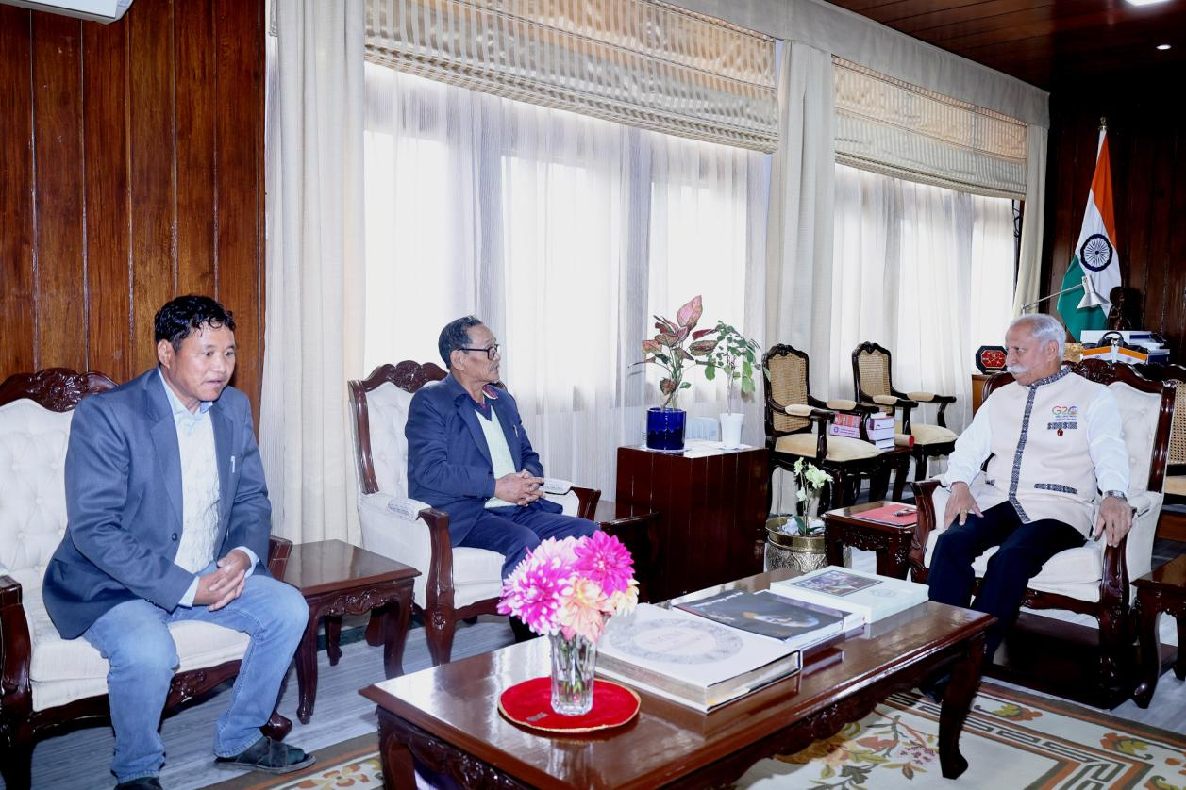
- Governor emphasizes the need for organic tea cultivation, highlighting its sustainability and strong market demand
- Governor advises tea growers to leverage both traditional and digital marketing strategies
- As a welfare State, the State Government would extend full support, including marketing assistance, provided tea growers adhere to quality standards, adopt sustainable farming methods, and maintain high production standards: Governor

The Governor of Arunachal Pradesh, Lt. General KT Parnaik, PVSM, UYSM, YSM (Retd.), interacted with representatives of the State’s Small Tea Growers at Raj Bhavan, Itanagar on 15th February 2025. They discussed strategies for promoting Arunachal Pradesh’s tea industry.
During the meeting, the Governor emphasized the need for organic tea cultivation, highlighting its sustainability and strong market demand. He encouraged tea growers to adopt natural farming practices, which enhance product quality and align with global consumer preferences for eco-friendly and chemical-free products.
Reaffirming the State’s commitment to strengthening its tea industry and positioning Arunachal Pradesh as a key player in the organic tea market, the Governor advised tea growers to leverage both traditional and digital marketing strategies. He urged them to develop a distinctive brand identity with an attractive logo, eco-friendly packaging, and a compelling tagline that reflects their commitment to organic and sustainable practices.
Stressing the importance of storytelling in branding, the Governor encouraged growers to share their farm’s journey, cultivation methods, and sustainability efforts through social media and product packaging. He also recommended creating a professional website with an integrated e-commerce platform to facilitate direct consumer sales. Additionally, he urged participation in national and international tea trade fairs to connect with buyers and expand market presence.
The Governor assured representatives that as a welfare State, the State Government would extend full support, including marketing assistance, provided tea growers adhere to quality standards, adopt sustainable farming methods, and maintain high production standards.
Shri Tadak Gab, President of the Small Tea Growers’ Association, and Shri Marpu Baja, a tea grower, apprised the Governor about issues related to the tea industry in Arunachal Pradesh.

