GOVERNOR’S SECRETARIAT
ARUNACHAL PRADESH
ITANAGAR

Press Communiqué

Dated Feb 15th, 2025

Mass cleanliness drive held at Bagra Circle, West Siang District
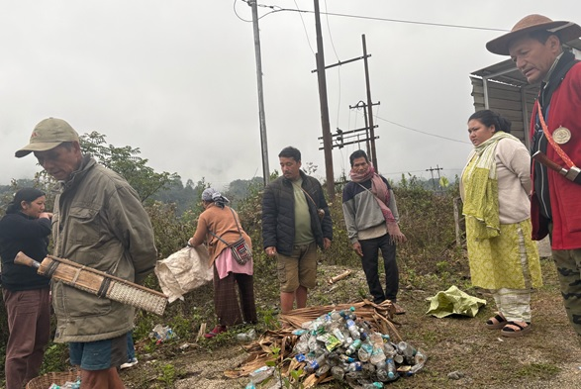

Bagra the 15th February 2025: A mass cleanliness drive was held at Bagra Circle, West Siang District under the initiative of “Dolu em Kaken be Molaju” (Let’s make villages beautiful) on 15th February 2025. Wherein, all together 16 villages participated, around 1600 people consisting of Panchayat Leaders, Goan Buras, SHGs, CBOs, Youths and general villagers. Smti Jumi Ete, APCS, Circle Officer Bagra along with Shri Minjom Bagra, HGB visited the villages to monitor the cleanliness drive and urged all the commuters not to throw garbage on public space particularly on the highway and roadside falling under the jurisdiction of Bagra Circle. It was also informed to the commuters and villagers that if anybody is found throwing garbage on public space of Bagra Circle then a FIR will be lodged against the Violators and action will be taken as per the relevant section of law. CO Bagra also encouraged the villagers to make the initiative of “Dolu em Kaken be Molaju” a grand success.
This initiative has recently been taken up by the Circle Officer Bagra in collaboration with Panchayat Leaders, Goan Buras, SHGs and Line Departments under the guidance of Ms Mamu Hage, Deputy Commissioner, West Siang District. Through this initiative the local administration has decided to conduct mass cleanliness drive in all the villages of Bagra Circle on 15th day of every month. This initiative aspires for overall development of villages- economically, politically, socially, educationally and ecologically.

