GOVERNOR’S SECRETARIAT
ARUNACHAL PRADESH
ITANAGAR

Press Communiqué

Dated Feb 15th, 2025

Massive Fire Devastates Tenga Market – Relief Efforts Underway
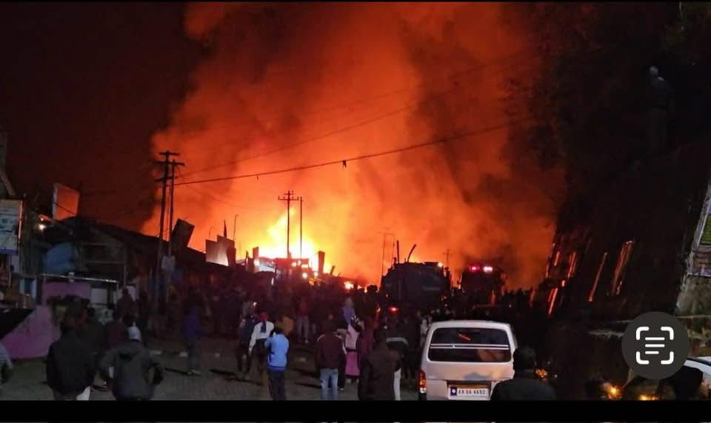

Tenga, 15 February: A devastating fire broke out in Tenga Market early this morning at around 3 AM, reducing approximately 47 shops and dozens of houses to ashes.
Upon receiving the report, ADC Singchung, Murnya Kakki, and DDMO I/C Phuntso Tashi rushed to the site in the early hours of the incident to oversee the response and ensure relief measures were initiated.
The District Fire Brigade was the first to reach the site and immediately began firefighting operations. However, due to the intensity of the fire, additional support was required. Deputy Commissioner of West Kameng, Smti Akriti Sagar (IAS), assessed the situation and immediately arranged additional water tankers from the Indian Army to aid in controlling the fire. With coordinated efforts between the District Fire Brigade and the Indian Army, the fire was successfully brought under control.
In response, the District Administration, in collaboration with all essential departments, set up a relief camp at Upper Primary School, Tenga, to provide shelter and assistance to the affected families. The Agriculture Department also donated vegetables and essential items to support the victims. DC Akriti Sagar (IAS) interacted with the affected families and assured them of full support and assistance from the government.
Local MLA Thrizino-Buragaon, Tenzin Nima Glow, rushed to the spot, extending generous donations and support to the affected families.
The District Administration expressed deep appreciation for the District Fire Brigade’s swift response and the Indian Army’s crucial role in providing additional firefighting support, urgent relief, medical care, and humanitarian aid to those affected.
Additionally, the Tenga Market Association and Bomdila Taxi Association extended their support by providing essential assistance to the victims.
Efforts are ongoing to support displaced families and restore normalcy in the area.|
