GOVERNOR’S SECRETARIAT
ARUNACHAL PRADESH
ITANAGAR

Press Communiqué

Dated Feb 14th, 2025

Educational & Awareness drive carried out in Likabali
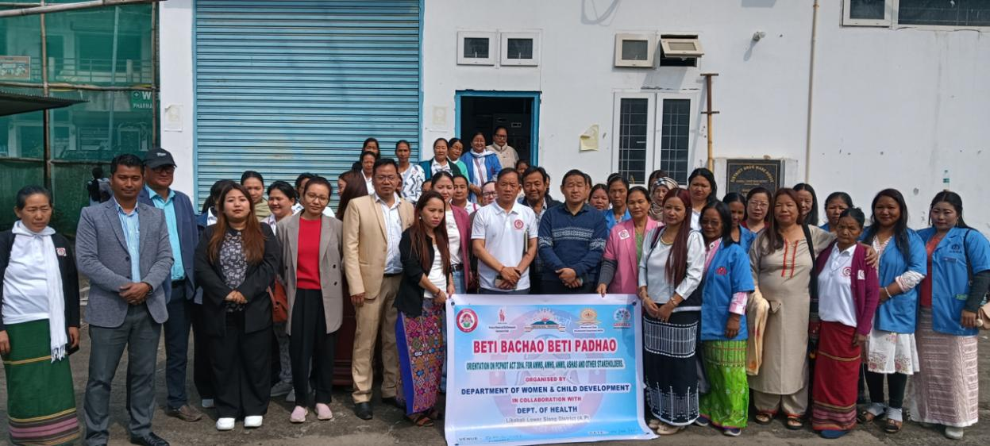
The department of women and Child Development Lower Siang District organised an educational-cum- awareness programme on PC & PNDT Act 2014 in collaboration with the district administration and the department of Health & FW with an aim to familiarize the frontline workers especially, the Anganwadi workers, ANMs, ASHAs and other stakeholders of Likabali about the Act. The main function was held at the District Hospital Likabali which was graced by Shri Rujjum Rakshap Deputy Commissioner and Shri Gothombu Dajangju, Superintendent of Police as guests.
The event also mark the beginning of a six-week long celebration commemorating the completion of 10 years of Beti Bachao, Beti Padhao campaign in the country. The district had launched its campaign on January 22nd last and which shall culminate on March 8th next.
While addressing the gathering the DC had underscored the importance of women empowerment and stated that the campaign would not succeed without active participation of women. He motivated the women folks to have a deep understanding of the content and purpose of the Act for its effective implementation and disseminate the same among their fraternity.
Dr. Binpi Karlo, Gynaecologist, District Hospital, Likabali spoke at length on the various provisions of the Act.
Meanwhile, the Child Development Project Officer cum District Nodal Officer, BBBP, Lower Siang District Jikom Doye gave the keynote address. He exhorted the attendees about how dropout rates among girl child can be minimized in the tribal society.
Among others present in the function were the district officers, Panchayat leaders, GBs, members of APWWS district unit. The other highlights of the daylong programme included mass tree plantation in the town in collaboration with the department of forest and envirenment.

