GOVERNOR’S SECRETARIAT
ARUNACHAL PRADESH
ITANAGAR

Press Communiqué

Dated Feb 11th, 2025

Review Meeting on Major Infrastructure Projects and Flagship Schemes Held in Likabali
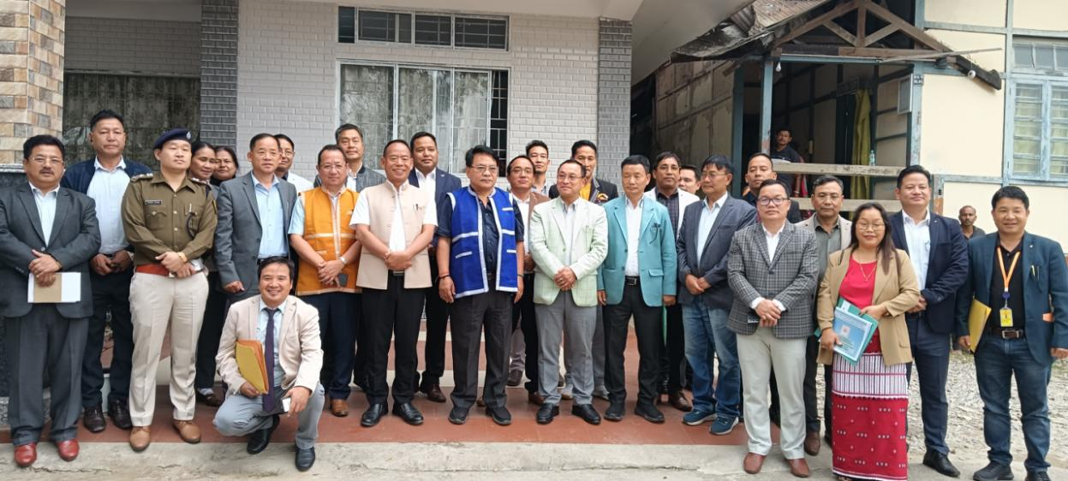

The first review meeting on major infrastructure projects and PM / CM flagship schemes was convened at the Conference Hall of Circuit House, Likabali by Shri Wangki Lowang, HM Environment & Forest, Geology , Mining & Minerals Development cum Guardian Minister for Lower Siang district today . While stressing on the need to align road projects within the state , he spoke on the significance of road connectivity- Pasighat -Ego-Garu-Gensi-Sibe to Tamen (247 KM) connecting Siang to Subansiri.
Lauding the district’s scope for religious tourism , he exhorted the administration to come up with innovative ideas to generate means of self employment and economic development. He also exhorted the department heads to have a thorough knowledge of the guidelines of various funding sources , it’s judicious use and discouraged surrendering funds due to delay. Duly Kamduk , secretary education cum Mentor secretary for the district, impressed upon the department heads to make all efforts to saturate PM and CM flagship schemes and to execute all works without compromising with the quality . He advised the working department to draw program evaluation and review technique (PERT) of every work in addition to financial & physical achievement while presenting the progress of work. Delivering the keynote address, Rujjum Rakshap requested the Guardian Minister and Mentor Secretaryto take up the district’s issues at the highest level for holistic development and requested for additional funds to develop border areas to ameliorate the living conditions of the people. Additionally , the Deputy Speaker APLA Kardo Nyigyor, 36- Nari - Koyu AC also spoke on the occasion . Various department heads gave ppt on the array of projects going on and put forth major hurdles faced while doing so . The meeting was also attended by ZPC Marpe Nguba , SP Gothambo Dajangju ADC Nari , HoDs and others.

