GOVERNOR’S SECRETARIAT
ARUNACHAL PRADESH
ITANAGAR

Press Communiqué
Dated Feb 10th, 2025

Deputy Chief Minister Chowna Mein Flags Off National Integration Tour for Arunachal Students
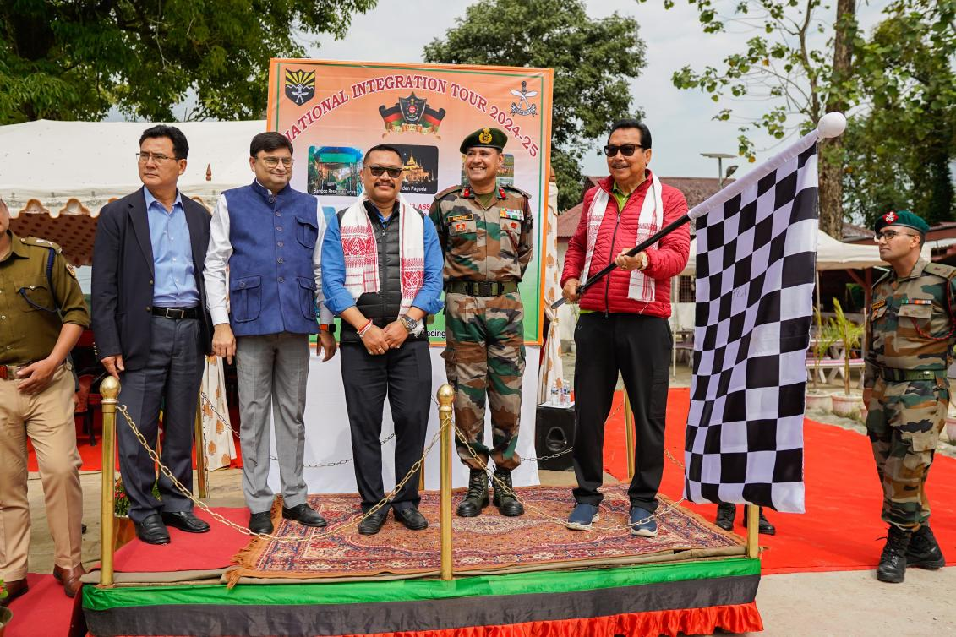
Namsai, February 10: Deputy Chief Minister Chowna Mein today flagged off the National Integration Tour, a 13-day initiative designed to strengthen national unity and promote cultural exchange among youth. The tour organised by the 11 Assam Rifles will take 30 talented girl students from Arunachal University of Studies (AUS), Namsai, on a journey to six significant locations across India.
“The National Integration Tour is not just a travel experience, but a chance to witness the diversity of India and embody the spirit of ‘Ek Bharat, Shreshtha Bharat,’” noted Chowna Mein. He added that the students will explore historical, cultural, and technological landmarks in Jorhat, Guwahati, Shillong, Kolkata, Dimapur, and Kohima, enabling them to gainvaluable insights into the heritage and advancements that define our great nation.
The Deputy Chief Minister also reflected on the journey of Arunachal University of Studies, which has grown from humble beginnings into one of the best educational institutions in the region. Today, Arunachal University of Studies stands as a beacon of quality education, with the best faculty and facilities that are shaping the future of theyouth and contributing significantly to the progress of the state.
He encouraged the students to make the most of this opportunity, to learn from each experience, and to return with a renewed sense of national pride, unity, and responsibility.
Further, appreciating the ongoing efforts of Assam Rifles in combating drug abuse and empowering the youth of Arunachal Pradesh, Mein noted that they play a crucial role in the state’s progress.
The 13-day tour will offer the students a chance to engage with diverse cultures and histories, from the picturesque landscapes of Jorhat to the vibrant city of Guwahati, the historical richness of Shillong, technological wonders in Kolkata, economic hubs in Dimapur, and the solemn World War II Cemetery in Kohima.
In his address, Deputy Chief Minister Chowna Mein praised the Assam Rifles for their outstanding contribution to national security and community development. He acknowledged their dedication to maintaining peace in the Northeast and fostering national integration through initiatives like this tour.
The event was attended by several distinguished dignitaries, including Advisor to the Minister of Sports & Youth Affairs, MLA Zingnu Namchoom; Commander of Headquarters 25 Sector Assam Rifles, Brigadier Sarabjeet Singh; Sena Medal, Commandant of 11 Assam Rifles, Colonel Vivek Tripathi; Second in Command of 11 Assam Rifles, 2IC H K Acharya; Namsai Company Commander of 11 Assam Rifles, Major Sushant Sharma; Vice Chancellor of Arunachal University of Studies (AUS), D.S. Hernwal; PRO of Arunachal University of Studies (AUS), Vishva Lochan; and SP of Namsai, Sange Thinley, along with army personnel and faculty members of AUS.
