GOVERNOR’S SECRETARIAT
ARUNACHAL PRADESH
ITANAGAR

Press Communiqué
Dated Feb 10th, 2025
Governor visits Parmarth Niketan Shivir, attends Sandhya Arti
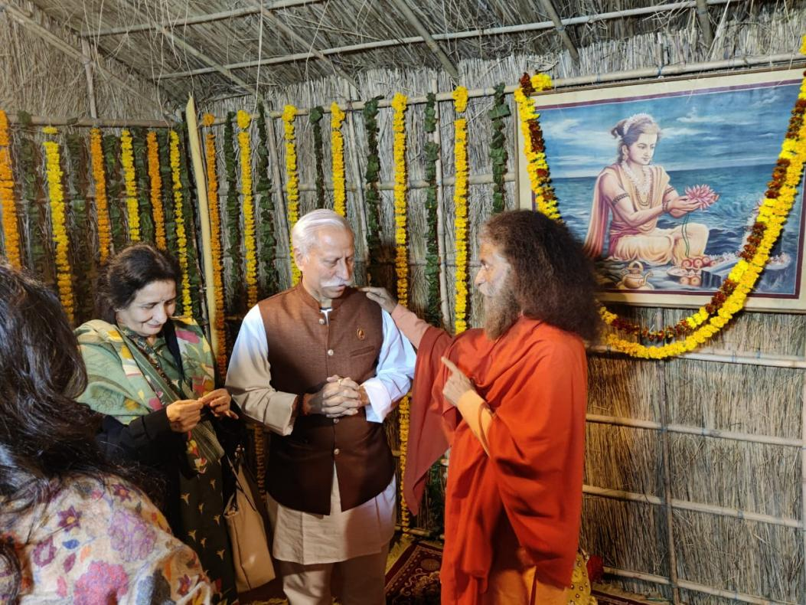
The Governor of Arunachal Pradesh, Lt. General KT Parnaik, PVSM, UYSM, YSM (Retd.), who is on a four-day visit to the State of Uttar Pradesh, visited the Parmarth Niketan Shivir in the Kumbh Mela area of Prayagraj on 10th February 2025. Accompanied by the First Lady of the State, Smt. Anagha Parnaik, the Governor was warmly received at the spiritual camp.
During their Shivir visit, the Governor and the First Lady of the State met Swami Chidanand Saraswati Ji, the revered spiritual head of Parmarth Niketan Ashram, a globally renowned spiritual institution based in Rishikesh, Uttarakhand. Engaging in a meaningful and insightful discussion, they exchanged religious and philosophical views, emphasizing the importance of spirituality in fostering peace, harmony, and social well-being.
Later in the evening, the Governor and the First Lady of the State witnessed the divine Sandhya Aarti, a deeply moving and spiritually uplifting ceremony held on the sacred banks of the Ganga. The mesmerizing Aarti, performed amidst the chanting of Vedic hymns and the glow of oil lamps, created a celestial ambiance, inspiring devotees and visitors.
