GOVERNOR’S SECRETARIAT
ARUNACHAL PRADESH
ITANAGAR

Press Communiqué
Dated Feb 11th, 2025

Awareness Program organised

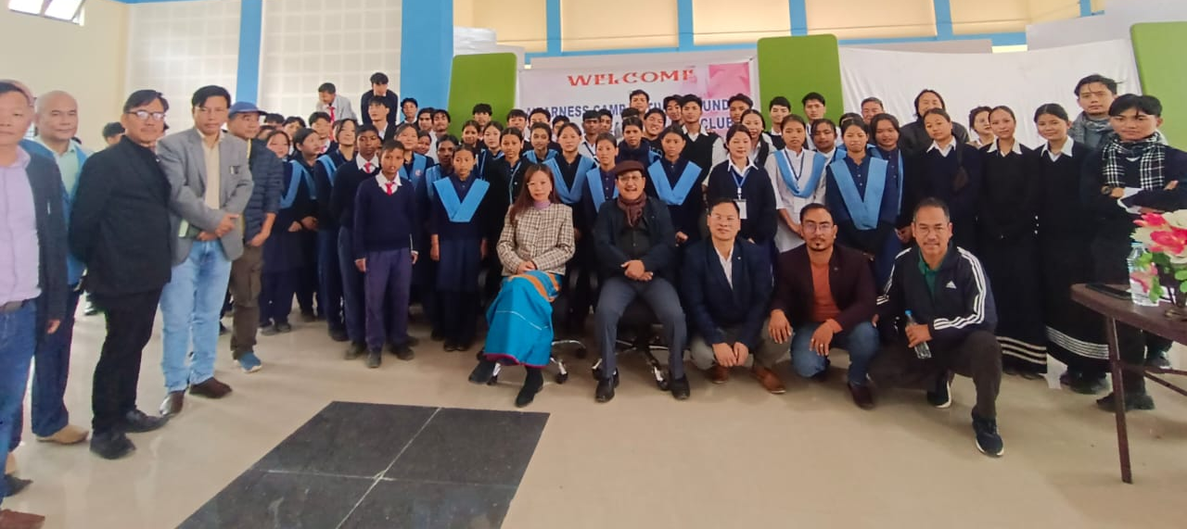

Aalo 10th Feb 2025, An awareness programme was organized by the Department of Education, West Siang District at Multipurpose Hall Aalo on 10th Feb 2025 under the “Pakke Declaration Eco Club” in alignment with “Pakke Tiger Reserve 2047 Declaration on Climate Change Resilient & Responsive Arunachal Pradesh” which was attended by around 250 students of GHSS Aalo & GHSS Nehru Memorial Aalo and nearby Upper Primary Schools of the district.
The campaign was elaborately explained by Mr. Yide Potom, RFO Aalo, Mr. Kennedy Bagra, Anti Drug Campaigner, Mr. Ajen Pujen from Health Dept. Aalo, Mr. Torik Ori, JE, UD & H Aalo as resource persons basing on the five themes of the declaration viz, Environment, Forest & Climate Change, Health & Well-being for all, Sustainable & adaptive living, Livelihoods & Opportunities and Evidence generation and collaborative actions.
The function was graced by Mrs. Mamu Hage, IAS, Deputy Commissioner, Aalo as Chief Guest wherein she advised the children to stay away from drugs and help in protecting the environment. She apprised the students about the declaration of the year of 2025 as the “Year of Youth” by the State Cabinet. She emphasized on focused academic performance and improvement especially in the CBSE result of Class-X & XII. She highlighted on the hazards of use of plastic, importance on the preservation of flora & fauna, maintaining cleanliness for healthy and hygienic environment. She also emphasized on leading a disciplined life to become a successful, meaningful and responsible citizen.

