GOVERNOR’S SECRETARIAT
ARUNACHAL PRADESH
ITANAGAR

Press Communiqué
Dated Feb 10th, 2025
Wangsu Emphasises Agricultural Development at Namsai Visit
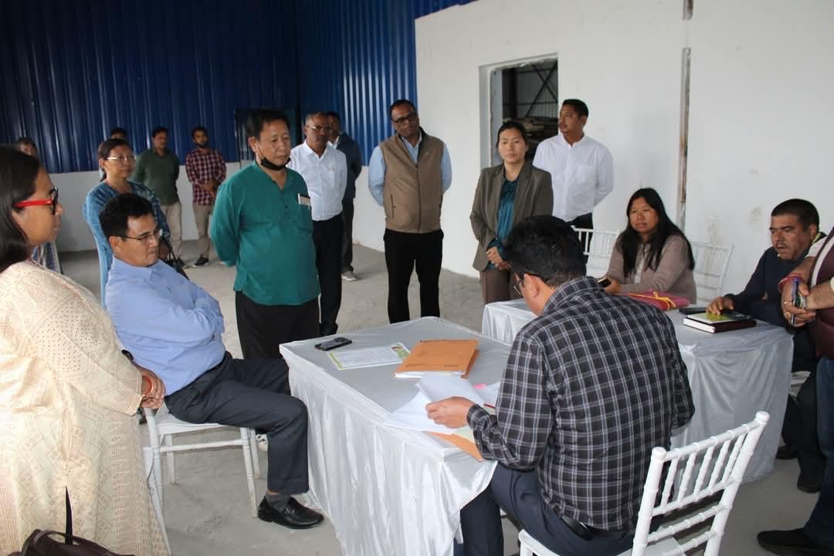
NAMSAI, Feb 10: Breed, seed and feed are important ingredients crucial for development of farm sectors, said Agriculture Minister Gabriel D. Wangsu, who conducted an extensive daylong tour of agricultural and allied sector facilities in Namsai district. The Minister, who holds multiple portfolios including Agriculture, Horticulture, Animal Husbandry & Veterinary, Fisheries and Food & Civil Supply, carried out detailed inspections of various facilities including the Namsai Dairy, Horti Nursery at Kherem and Farmer Training Centre. His itinerary also included visits to private pig farms in Emphum Village, local fisheries farms and the ongoing bio-fertilizer unit construction at Nanam Khamti Village. Minister Wangsu called for the need for collaborative efforts to address current challenges highlighted by the officers during the tour, particularly in the areas of fodder, feeds and seeds. “Every upcoming initiative should be data driven for proper and effective implementation, especially while procuring breed, seed or feed for our farmers,” he stated.
During a comprehensive review meeting held at the DC's conference hall, department heads presented detailed reports on their research activities, achievements and operational status to the minister.
Wangsu in his address called for the need for strict quarantine measures on imported products to safeguard the state's farming sector from disease. He also stressed the importance of a more targeted approach to distributing agricultural inputs and tools, ensuring farmers receive the specific resources they need, rather than a generic distribution. He urged officials to identify genuine farmers and prioritize attracting more young people to the field, expressing concern over declining farmer numbers and emphasising the crucial role of a strong primary agricultural sector for the overall economy. He also called for transparency and fairness in selecting beneficiaries for farmer-centric schemes.
The meeting was attended by C R Khampa, DC, DAO, DFDO, DVO, DPO, DFCSO, ADO, HDO, FO and officials of the departments.
Minister also attended the Scientific Advisory Committee (SAC) meeting organized by Krishi Vigyan Kendra, Namsai, where he engaged with senior scientists and researchers who presented their ongoing projects. He stressed the importance of working with local germplasm and identifying gray areas that need attention, offering his intervention where necessary.
This visit of Wangsu is part of his ongoing tour of districts across the state to assess regional strengths and challenges in the agricultural sector.

