GOVERNOR’S SECRETARIAT
ARUNACHAL PRADESH
ITANAGAR

Press Communiqué
Dated Jan 6th, 2025

Deputy Chief Minister of Arunachal Pradesh Graces the Hoisting of High Mast National Flag in Mechukha, Inspects Key Development Projects

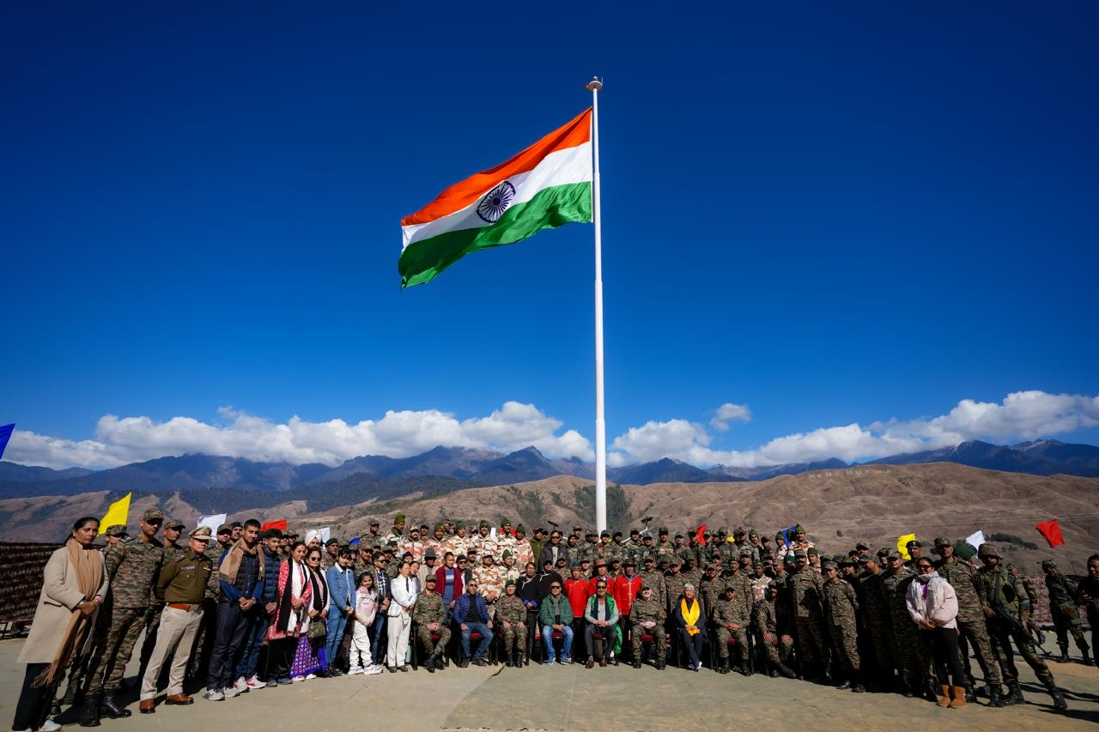

Mechukha, January 6: The Deputy Chief Minister of Arunachal Pradesh, alongside GoC 3 Corps Lt. General Abhijit Pendharkar in presence of Minister of Education, Tourism, RWD, etc. Pasang Dorjee Sona, Major General Akash Johar among others.
The ceremony, organized by the 13 Grenadiers (Ganga Jaisalmer) of the Indian Army marked a key moment of pride and unity for the region. The 72-feet-high mast displayed the National Flag proudly, reinforcing the message of national pride, security, and unity.
The Deputy Chief Minister, in his address, shared his deep appreciation for the overall experience he had during his visit to Mechukha. He acknowledged the outstanding work of the Indian Army in the region, particularly the 13 Grenadiers of Indian Army and ITBP, who have not only ensured the security of the borders but also actively contributed to the social and economic upliftment of the region. He also assured to sanction for the construction of 4.5 MW Hydropower Project on Yargyapchu river to meet the power requirements of the Mechukha township.
During his 5 day visit, the Deputy Chief Minister also conducted a series of inspections and site visits to key development projects in the region. He visited the Lamang Border, underscoring its strategic importance, and inspected the site for the construction of a 4.5 MW Hydropower Project on the Yargyapchu river.
The Deputy Chief Minister also visited under-construction bridge over the Thargelling village, the PMGSY road to Thargelling Village, and the Rainbow Trout Hatchery Farm at Dechenthang. His visits highlighted the ongoing efforts to improve infrastructure, promote local development, and enhance the quality of life for the people of Mechukha and surrounding areas.
He also explored several notable religious and cultural landmarks, including the New Gompa, Samten Yangchag Monastery (Old Gompa), Neh-Pema Shelphu Drupkhang, and the Gurudwara at Tapo Asthan.
13 Grenadiers (Ganga Jaisalmer), currently deployed in Mechukha since October 9, 2021, is one of the oldest and most distinguished battalions of the Indian Army. With a history dating back to 1465 as part of the Bikaner State Forces, the battalion has continually upheld its legacy with exemplary service. In its present tenure, 13 Grenadiers has not only ensured the security of the region but has also contributed significantly through various Sadbhavana (goodwill) projects aimed at the holistic development of Mechukha Valley.
Among others, Commissioner Education Amzad Tak, Superintendent of Police S.K. Thongdok, and ADC Mechuka Tana Yaho were also present.
