GOVERNOR’S SECRETARIAT
ARUNACHAL PRADESH
ITANAGAR

Press Communiqué
Dated Jan 26th, 2025

76th Republic Day Celebrations in Yupia, Papumpare

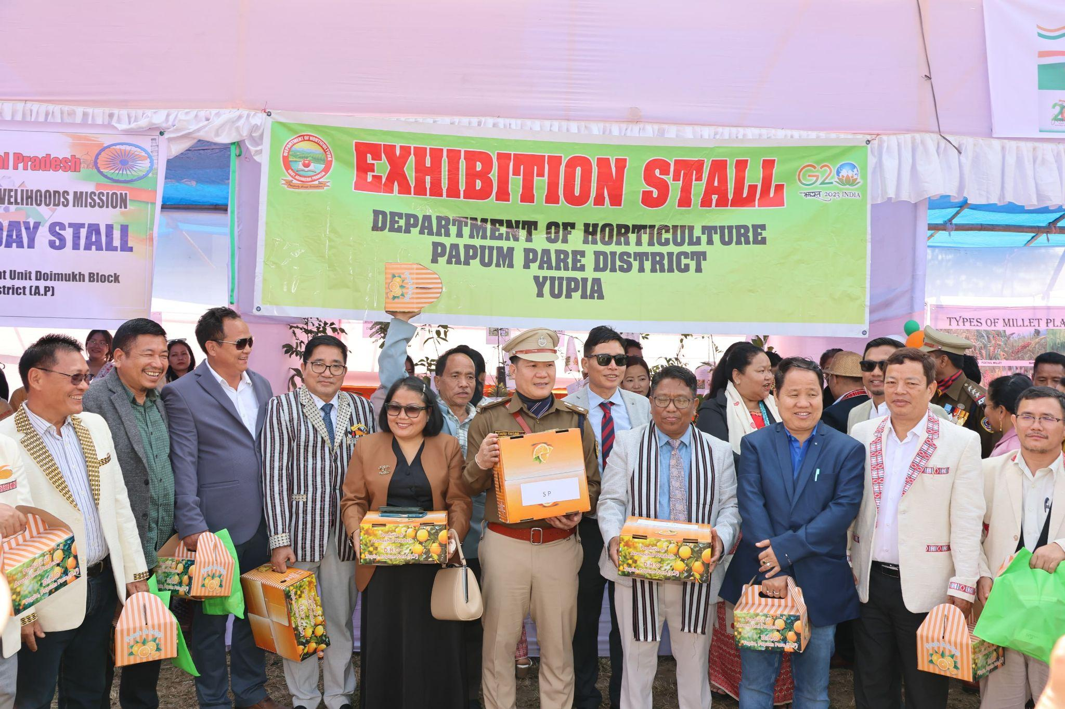

The 76th Republic Day was celebrated with great enthusiasm in Yupia, Papumpare, along with the rest of the nation. Deputy Commissioner Shri Jiken Bomjen graced the occasion as the Chief Guest. In his address, DC Bomjen paid tribute to the freedom fighters, defense forces, and the silent voters who have contributed to building a self-reliant and prosperous nation.
He highlighted various welfare initiatives by the Central Government and encouraged citizens to make use of the schemes available in sectors such as agriculture, health, tourism, and industries. The DC also announced a Mega Health Camp scheduled for February 4 at the District Hospital, Doimukh, and urged officials to focus on community service.
As part of the Republic Day celebrations, Certificates of Commendation were awarded, followed by the inauguration of stalls by various departments and agencies. The event concluded with vibrant cultural performances, Taekwondo demonstrations, and safety drills by the NDRF. Tokens of appreciation and prizes were distributed to participants and competition winners, marking a successful and engaging event.
