GOVERNOR’S SECRETARIAT
ARUNACHAL PRADESH
ITANAGAR

Press Communiqué
Dated Jan 26th, 2025

Pasighat Celebrates 76th Republic Day with Enthusiasm

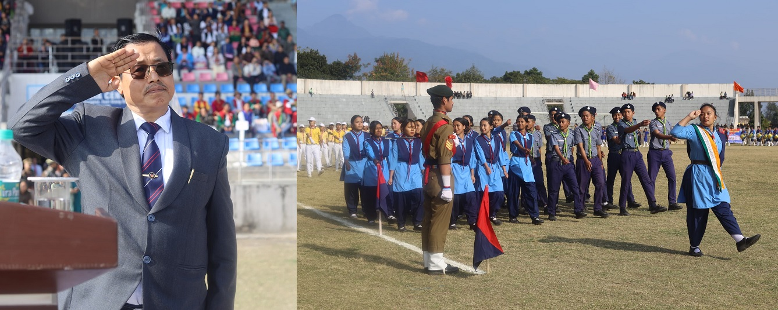

Pasighat joined the nation in celebrating the 76th Republic Day on Sunday with great enthusiasm and reverence. The national tri-colour was unfurled by East Siang Deputy Commissioner, Tayi Taggu, at the Pasighat Outdoor Stadium. Following the flag hoisting, a grand march past by thirteen contingents, led by Parade Commander Inspector Samuel Pertin, took place in the presence of MLA Tapi Darang, SP Pankaj Lamba, prominent officers, retired bureaucrats, and the public.
In his address, DC Taggu expressed gratitude to Dr. B.R. Ambedkar, the architect of the Indian Constitution, for shaping a vibrant and prosperous India. He also thanked Prime Minister Narendra Modi and Chief Minister Pema Khandu for their visionary leadership and transformative actions. He highlighted the East Siang District Administration's commitment to responsive and timely service delivery.
The DC informed the gathering about the ongoing construction projects under the Smart City Mission and shared the district's achievements in health, education, agriculture, and other sectors. School children presented patriotic songs and dances that captivated the audience. Commendation certificates were distributed by DC Taggu, MLA Tapi Darang, and SP Pankaj Lamba to individuals for their dedicated services. The DC also inaugurated exhibition stalls from various departments.
The event also included a “Pledge Against Drug Addiction,” led by MLA, DC, and SP, followed by cultural performances, a "Rope Mallakhamb" display, and Taekwondo demonstrations that delighted attendees.
Ruksin Celebrates 76th Republic Day
Meanwhile, the 76th Republic Day was celebrated at Ruksin ADC Headquarters with a large gathering at the Ruksin General Ground. The National Flag was unfurled by ADC Ruksin, Kiran Ningo, who urged the residents of the sub-division to uphold the ideals of the Indian Constitution and contribute to the nation's progress with dedication. Pasighat West MLA Ninong Ering, public leaders, ZPMs, senior citizens, government officers, and cultural troupes attended the event.
The day featured patriotic cultural performances, including folk dances by students and cultural troupes from nearby villages. Additionally, various departments, self-help groups, and Patanjali Oil Palm Company from Niglok showcased their schemes and products. Among the recipients of Commendation Certificates were Shri Tajom Padung, Principal of Government Higher Secondary School Ruksin, and Shri Jacob Paron, a prominent social worker.
