GOVERNOR’S SECRETARIAT
ARUNACHAL PRADESH
ITANAGAR
Press Communiqué
Dated Jan 8th, 2025

Farmers Present "Harvest of the Month" to
Chief Minister
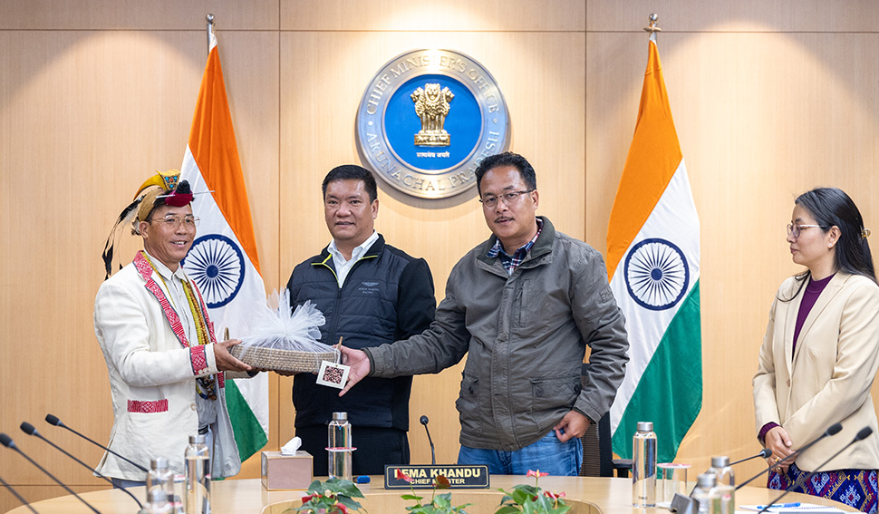

Itanagar, Jan 8: Agriculture and Horticulture Minister, Gabriel D. Wangsu, led a delegation of progressive farmers to present the "Harvest of the Month" to the Chief Minister. This initiative, launched in September 2024, aims to showcase seasonal produce, encourage farmers and promote horticulture farming in the state.

The ‘Harvest of the Month’ program provides a platform to progressive farmers or government farms to present their produce to the Chief Minister, while also presenting the challenges and opportunities in cultivating the crop. This month, farmers from various districts showcased oranges, kiwis, persimmons, walnuts and large cardamom.

During the meeting, farmers raised concerns such as the need for improved market access, including addressing issues like premature kiwi harvesting due to market demands and the inability to sell organic produce at premium prices. They also highlighted challenges like logistical hurdles, particularly for transporting produce, and the impact of traditional cultivation methods on large cardamom production, leading to increased disease susceptibility.

Farmers requested support in various areas, including the establishment of nurseries, improved transportation infrastructure, reliable electricity and road connectivity, and smoother access to Atma Nirbhar bank loans.

While acknowledging their challenges, highlighted the importance of obtaining disease-free saplings from government nurseries to combat crop diseases. He stressed the need for organized farmer societies to collectively address challenges and improve market access.

The Chief Minister stressed the importance of organized farming within Arunachal Pradesh, encouraging farmers to collaborate rather than compete. He emphasized the potential of the agriculture and horticulture sectors and the government's commitment to supporting farmers. To enhance market access, the government has partnered with the ITBP and Army to facilitate the procurement and distribution of farmer-produced goods through the marketing board.

The farmers expressed gratitude to the government for its ongoing support while reiterating the need for nurseries, better infrastructure, and timely assistance.

The Chief Minister urged the Department of Horticulture to identify key issues and implement structured solutions for farmers' benefit. Minister Wangsu, accompanied by the Secretary and Director of Horticulture, presented the farmers and their produce to the Chief Minister.

The progressive farmers selected this month were Shri Talum Tabing, Siang District, an orange farmer earning, Shri Hage Jarjo, Lower Subansiri, a kiwi farmer, Shri Bodumba, West Kameng, apples, kiwis and persimmons farmer, Shri Tashi Nampo, Dirang, a walnut farmer, Shri Ngurang Takap, Papum Pare, a large cardamom farmer.

