GOVERNOR’S SECRETARIAT
ARUNACHAL PRADESH
ITANAGAR
Press Communiqué
Dated Jan 9th, 2025

Tirap District Administration Prepares for 76 th Republic Day Celebration
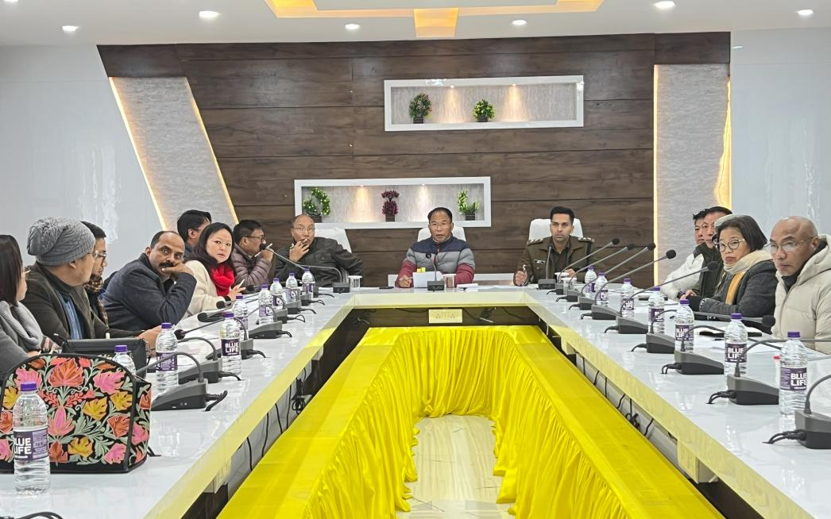
Khonsa, January 8, 2025 – A coordination meeting was convened today in Khonsa to discuss preparations and work distribution for the upcoming Republic Day celebrations. The meeting was chaired by the Deputy Commissioner of Tirap District, Techu Aran.
Addressing the gathering, the Deputy Commissioner underscored the significance of Republic Day and stressed the need for active participation from all stakeholders, including government departments, security forces, and civil society organizations, to ensure the event’s success.
Following extensive deliberations, various responsibilities were allocated to different departments, the Khonsa Bazar Welfare Committee, and Women Self-Help Groups (SHGs). Additionally, it was announced that parade rehearsals would commence soon at Nehru Stadium, Khonsa, under the supervision of Superintendent of Police Tirap, Singjatla Singpho.
The meeting saw participation from heads of departments, ADC Headquarters Tana Bapu, administrative officers, ASP Aditya Singh (IPS), CO 36Bn CRPF Lamkhokam Lhoujem, representatives from 44 Assam Rifles, as well as members of NGOs and SHGs.
The District Administration urged all participants to give their best efforts in making the 76th Republic Day celebrations a grand and memorable occasion.
