GOVERNOR’S SECRETARIAT
ARUNACHAL PRADESH
ITANAGAR
Press Communiqué
Dated Jan 9th, 2025

IG ITBP calls on the Governor
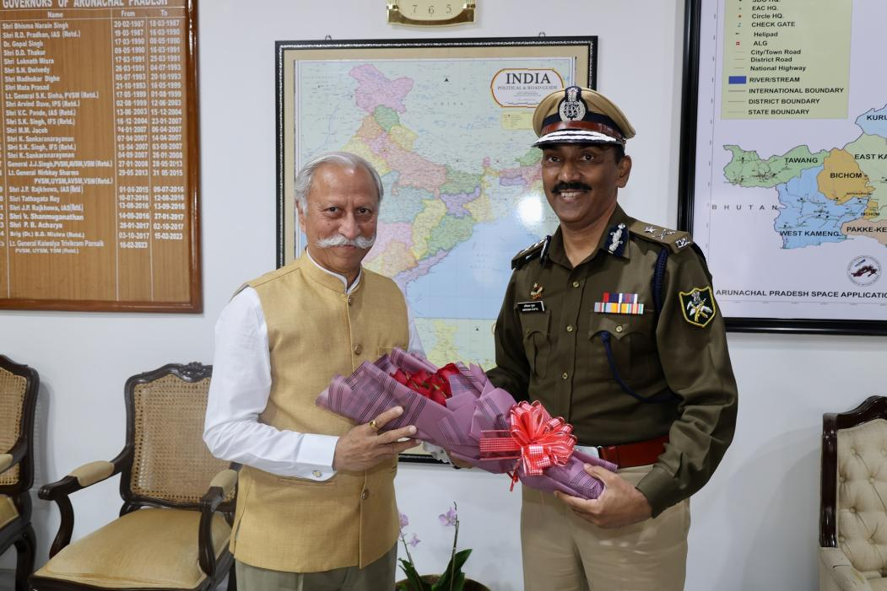

- Governor commends the role and contributions of the ITBP in Arunachal Pradesh.
- Contribute in a collaborative efforts aiming at developing the border areas, particularly through the Vibrant Border Village program: Governor to ITBP
- Actively promote recruiting local youth into the armed forces: Governor to ITBP.

Shri Amitabh Gupta, Inspector General, North East Frontier, Indo Tibetan Border Police, Itanagar, called on the Governor of Arunachal Pradesh Lt. General KT Parnaik, PVSM, UYSM, YSM (Retd.) at Raj Bhavan, Itanagar on 9th January 2025. They discussed border security and management, vibrant village programme and other issues related to the State.
The Governor, while acknowledging the commendable role and contributions of the ITBP in Arunachal Pradesh, recommended that ITBP to contribute in a collaborative effort aiming at developing the border areas, particularly through the Vibrant Border Village program. He said that such endeavour will be in the national interest and the mutual benefits for both the local communities and the ITBP.
Sharing his experience in border management, the Governor advised on the involvement of local people. He also highlighted the importance of regular training, drills, and spontaneous patrolling.
The Governor advised the NE Frontier head to actively promote recruiting local youth into the armed forces. He also urged the ITBP to offer timely humanitarian support during emergencies in the border regions.
Shri Gupta, who recently assumed charge of the NE Frontier HQ, assured the Governor that the concerns raised would be promptly addressed.

