GOVERNOR’S SECRETARIAT
ARUNACHAL PRADESH
ITANAGAR
Press Communiqué
Dated Jan 9th, 2025

Tawang Market Area Secured with Comprehensive CCTV Monitoring

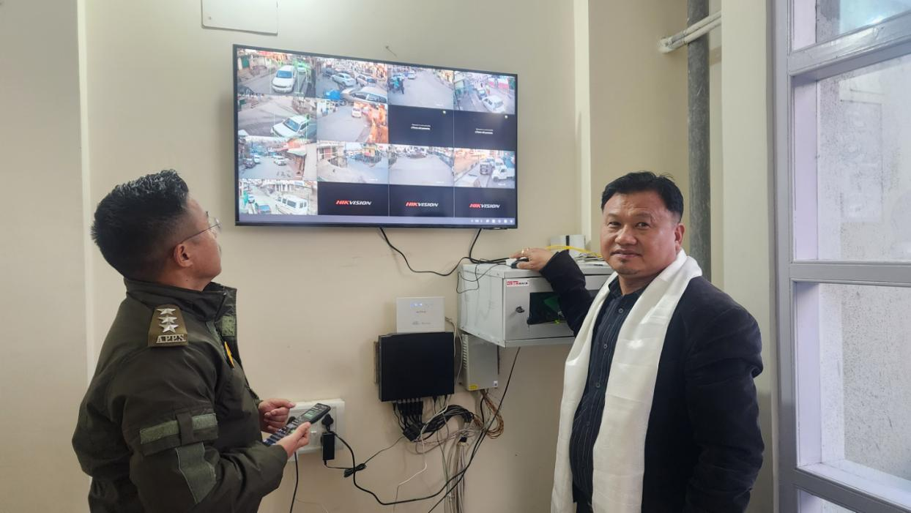

Tawang, January 9, 2024 – In a significant step towards enhancing the safety and security of Tawang’s bustling market areas, particularly during peak tourist seasons and VVIP movements, Deputy Commissioner (DC) Tawang, Kanki Darang, officially launched the CCTV installation project at Nehru Market today.
This initiative extends CCTV coverage from the Nehru Market tri-junction to the Old Market tri-junction, bringing the three primary markets of Tawang under robust surveillance. The launch event was attended by Dy.SP Tawang Tasso Kato, Bazar Secretary Nehru Market Tsangpa Tashi, other executive members of the Bazar Welfare Committee, and police personnel.
Implemented under the supervision of District Information Technology Officer, Tenzin Phuntsok, and funded through the DC Untied Fund, this initiative strengthens security measures in key market areas. The Old Market and parts of the New Market have been under CCTV monitoring since April 2023, and with the addition of Nehru Market, a more comprehensive surveillance system is now in place. Further expansion to cover the remaining areas of the New Market is planned for the near future, as announced by DC Tawang.
Expressing their appreciation, the Bazar Secretary and members of the Bazar Welfare Committee extended their gratitude to DC Tawang for prioritizing market security through this proactive measure. Dy.SP Tawang highlighted the effectiveness of the surveillance system, citing a recent theft case that was successfully solved using CCTV footage provided by both the administration and private shop owners.
The comprehensive CCTV monitoring system is expected to significantly enhance security, streamline traffic management, and deter criminal activities, ensuring a safer and more organized environment for residents, businesses, and visitors in Tawang.

