GOVERNOR’S SECRETARIAT
ARUNACHAL PRADESH
ITANAGAR
Press Communiqué
Dated Jan 9th, 2025

HCM attend review meeting with HoD's of West Siang Aalo

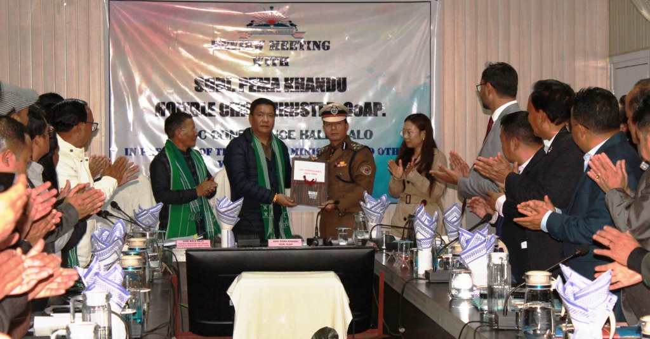

Aalo the 9th January 2025: Hon'ble Chief Minister of Arunachal Pradesh Shri Pema Khandu chaired the review meeting of West Siang at DC's Conference Hall Aalo along with Sri Balo Raja Hon'ble Minister UD & Housing, Land Management etc. the meeting was conducted to review the progress of developmental projects of West Siang District.
Ms Mamu Hage (IAS) Deputy Commissioner West Sang warmly welcome the HCM and his team and highlighted the progress of major projects of West Siang in PowerPoint Presentation. Eleven Major Govt Projects were highlighted and discussed on the progress of the work.
DC informed that all the major projects are going smoothly except few. By 2025 few projects will be completed as per time. She informed. DC also highlighted the initiatives of District administration for beautification of Aalo township and other initiatives.
HCM inaugurated the City Surveillance projects and handed over to SSP/DIGP Aalo. Under the city surveillances 10 CC cameras were installed in various strategic locations of Aalo township for easy tracking.
T.Amo(IPS) SSP/DIGP Aalo presented the various initiatives of District Police and presented before HCM and many criminal cases, drug peddlers, traffic violators etc were checked, He Informed.
Sri Balo Raja Hon Minister UD & Housing, Land Management etc and Guardian Minster of West Siang, Leparada, Shi-Yomi etc informed all the District administrators, HoD's and HMLA's of each Districts to work as a team for the better development of District. He informed that as a Guardian Minister, He will convened a meeting with all the DC's, SP's, HoD's and MLAs of his Jurisdiction to review the progress of projects and issues of each District.
HCM informed that in Arunachal Pradesh each district have a different problems while undertaking any projects due to the differences in topography. The Govt of Arunachal Pradesh is inclusive in Governing. He also informed that with the blessing of Our Hon Prime Minister of India Sri Narendra Modi Arunachal is changed in every fronts of developmental projects. The performance of developmental projects in the District is important. He informed the District Officers to dedicated for overall development of ones dept as well as District.
Due to limited Govt Job the Govt of Arunachal have started many self employment opportunities like entrepreneurship, Startup etc. State and Central Schemes of the Govt is to be known by the every individuals and to avail them.
Recently the Govt have appointed Guardian Ministers, Mentor Secretaries for every District to look after the issues, problems and monitoring of the various schemes of the Govt, He informed.
By 16 & 17 January HCM will convene a meeting with all DC's Guardian Ministers, Secretaries to chalk out the proper planning from District to state level so that the Govt can have knowledge of every districts performances and review on it. Cabinet meeting will be held in every District in the days to come, HCM informed.
Sri Tamo Riba ADC Kamba thanks the HCM and members present.
The review meeting was attended by Sri Topin Ete HMLA, Pesi Jilen HMLA, Nyabi Jini Dirchi HMLA, Tumpe Ete ZPC West Siang, Mamu Hage IAS DC West Siang, T Amo SSP/DIGP, Prince Kumar(IAS) Assistant Commissioner, ADC's, Admin Officers and HoD's of West Siang.

