GOVERNOR’S SECRETARIAT
ARUNACHAL PRADESH
ITANAGAR

Press Communiqué
Dated Jan 3rd, 2025

HDCM Chowna Mein Inaugurates Dorjee Sempa Khorchen and NCDS Multipurpose Building at Mechukha; Lays Foundation Stones for Key Development Projects

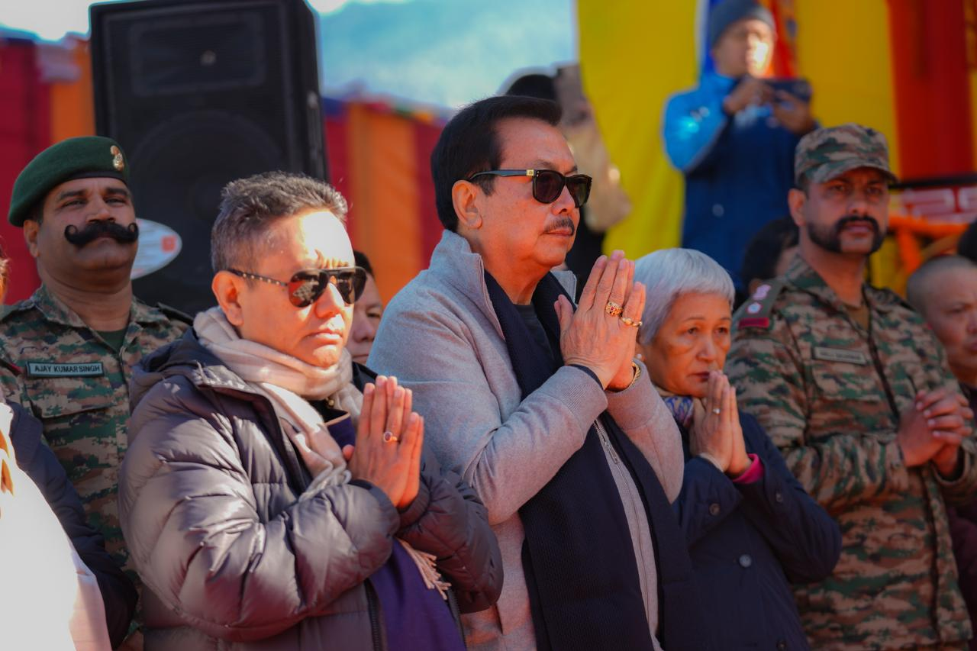

Mechukha, 3rd January – Deputy Chief Minister of Arunachal Pradesh, Chowna Mein, inaugurated the Dorjee Sempa Khorchen and the NCDS Multipurpose Building at Mechukha today, in the presence of the Minister of Education, Tourism, RWD, Library, and Parliamentary Affairs, Passang Dorjee Sona. These milestones mark a significant step forward in the development and cultural preservation of the region. Additionally, the Deputy CM also laid foundation stones for several development projects aimed at boosting local infrastructure and tourism potential.
The Dorjee Sempa Khorchen has been constructed in memory of the late former Minister Pasang Wangchuk Sona and his wife Rinjin Drema Sona and consecrated by His Eminence Rev. Dzogchen Ganor Rinpoche, the abbot of Lhagon Jhangchu Choeling Monastery, Tezu today.
This prayer wheel (Korchen), the tallest in India, houses 1.6 billion prayers and 16 Dungyur scrolls, each containing 10 crore prayers. In his address, Deputy CM Mein extended his heartfelt New Year greetings to the people of Mechukha and to all the people of Arunachal Pradesh. He expressed his gratitude to Minister P.D. Sona, his family and people of Mechukha for their warm hospitality.
In his address, Deputy CM Mein fondly recalled his association with the late Pasang Wangchuk Sona and praised his lasting contributions to Mechukha’s development. "His son, P.D. Sona, continues to uphold his father’s vision by championing progress in development and cultural preservation," Mein noted, commending P.D. Sona’s tenure as an exceptional Speaker of the Arunachal Pradesh Legislative Assembly. Mein emphasized the importance of highlighting and preserving Mechukha's unique cultural heritage. "Mechukha’s culture is incredibly rich and deserves to be showcased across Arunachal Pradesh," he stated, lauding the state government’s efforts to safeguard indigenous traditions through the establishment of the Department of Indigenous Culture.
The inauguration of the Dorjee Sempa Khorchen and the NCDS Multipurpose Building represents a positive stride toward Mechukha’s development.
He further said, "This magnificent monument will serve as a major tourist attraction and a place of pilgrimage for Buddhists from across the country and beyond.” Reaffirming the state government’s commitment to Mechukha’s progress, Deputy CM Mein announced plans for additional funding to drive development initiatives. He also shared plans to explore a small hydropower project to address the area’s growing energy needs.
Highlighting the growing popularity of Mechukha as a tourist destination, Deputy CM Mein remarked, "In recent years, we have seen a significant rise in tourists visiting from across the country. Mechukha is emerging as one of the most sought-after destinations." He expressed optimism about Mechukha’s bright future in regional development and tourism. The Deputy CM also laid foundation stones for several key projects, including the Mechukha Adventure Park, a Convention Hall, the Mechukha Cultural Haat, a motorable suspension bridge over the Yargyapchu River at Thargelling Village and construction of a connecting road to PMGSY Road to Thargelling Village, which are expected to enhance Mechukha’s infrastructure and tourism potential significantly. The newly inaugurated NCDS Multipurpose Building, a three-story structure, features guest rooms for monks, a meditation hall, office of Neh-Nang Cultural Development Society, and a conference hall, further bolstering the region's facilities. Speaking on the occasion, Minister Pasang Dorjee Sona expressed his heartfelt thank to all those who supported in the construction of the Dorjee Sempa Korchen which will serve as a place of worship for the people of Mechukha. Earlier, Deputy CM Mein along with the dignitaries visited the Civil Terminal Building at ALG Mechukha, the Indoor Stadium, and the Buddha Park, underscoring the importance of infrastructural growth in the area.

Among other present were SP S.K. Thongdok, ADC Mechukha Smt. Tana Yaho, Lt. Colonel Anush Sharma of the 13 Grenadiers, Indian Army, HoDs, PRI Leaders, GBs and members of the Neh-Nang Cultural Development Society.

