GOVERNOR’S SECRETARIAT
ARUNACHAL PRADESH
ITANAGAR

Press Communiqué
Dated Jan 3rd, 2025

Chief Minister calls on the Governor
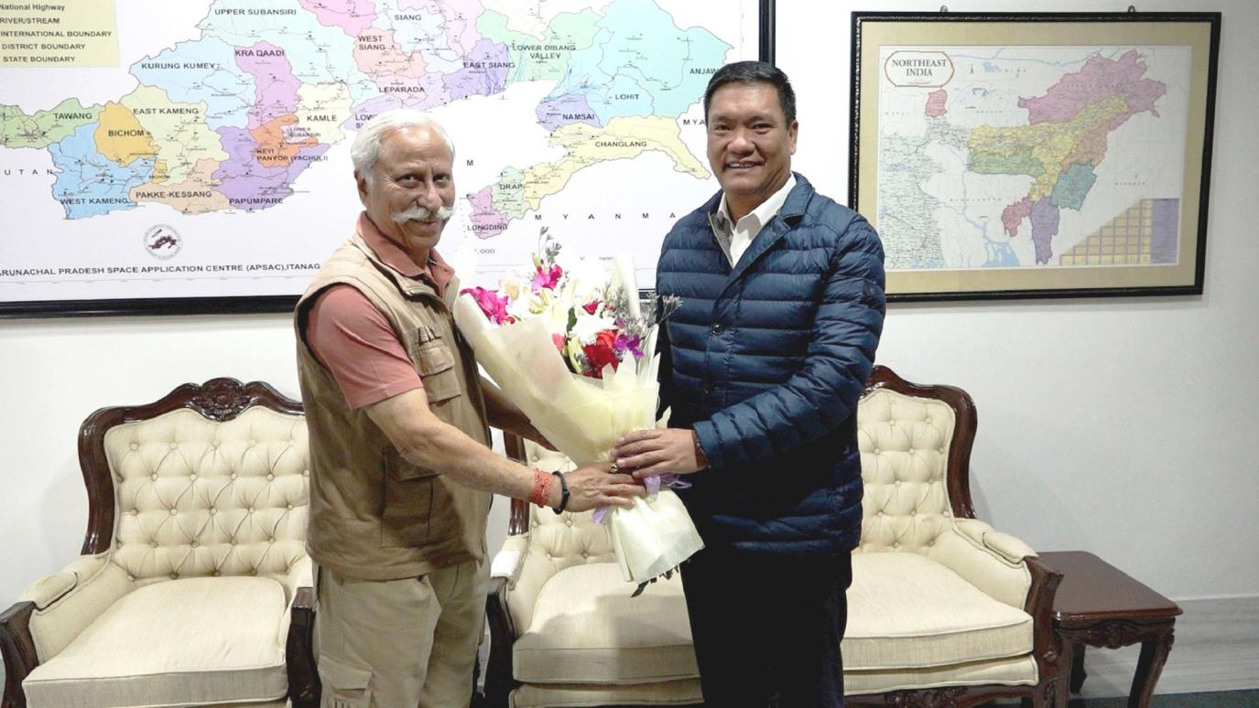

The Chief Minister Shri Pema Khandu called on the Governor of Arunachal Pradesh Lt. General KT Parnaik, PVSM, UYSM, YSM (Retd.) at Raj Bhavan, Itanagar on 3rd January 2025. In their first meeting in the New Year, they exchanged greetings and good wishes. They also discussed focus areas of development, outlining the developmental vision for the State in 2025.
The Governor commended the Chief Minister for prioritizing critical areas such as youth empowerment and a comprehensive overhaul of the education sector. Highlighting the pivotal role of youth in shaping the state’s future, the Governor encouraged initiatives that would equip young individuals with the necessary skills and create robust opportunities for self-reliance and entrepreneurship.
Recognizing the State's rich cultural heritage and natural beauty, the Governor underscored the untapped potential of tourism. He recommended the development of sustainable tourism as another key focus area, which could provide substantial self-employment opportunities for the youth while boosting the state's economy.
Emphasizing the importance of efficiency and transparency in governance, the Governor advised the Chief Minister to implement advanced monitoring mechanisms for development projects. He suggested automation of departmental processes starting from the district and circle levels to ensure timely execution and accountability in project delivery.
The meeting reflected a shared commitment between the executive and gubernatorial leadership of Arunachal Pradesh towards accelerating development, fostering youth engagement, and achieving excellence in governance in the year ahead.
