GOVERNOR’S SECRETARIAT
ARUNACHAL PRADESH
ITANAGAR

Press Communiqué
Dated Jan 31st, 2025

CRECHE AT IPR; IPR BIDS FAREWELL TO DIRECTOR
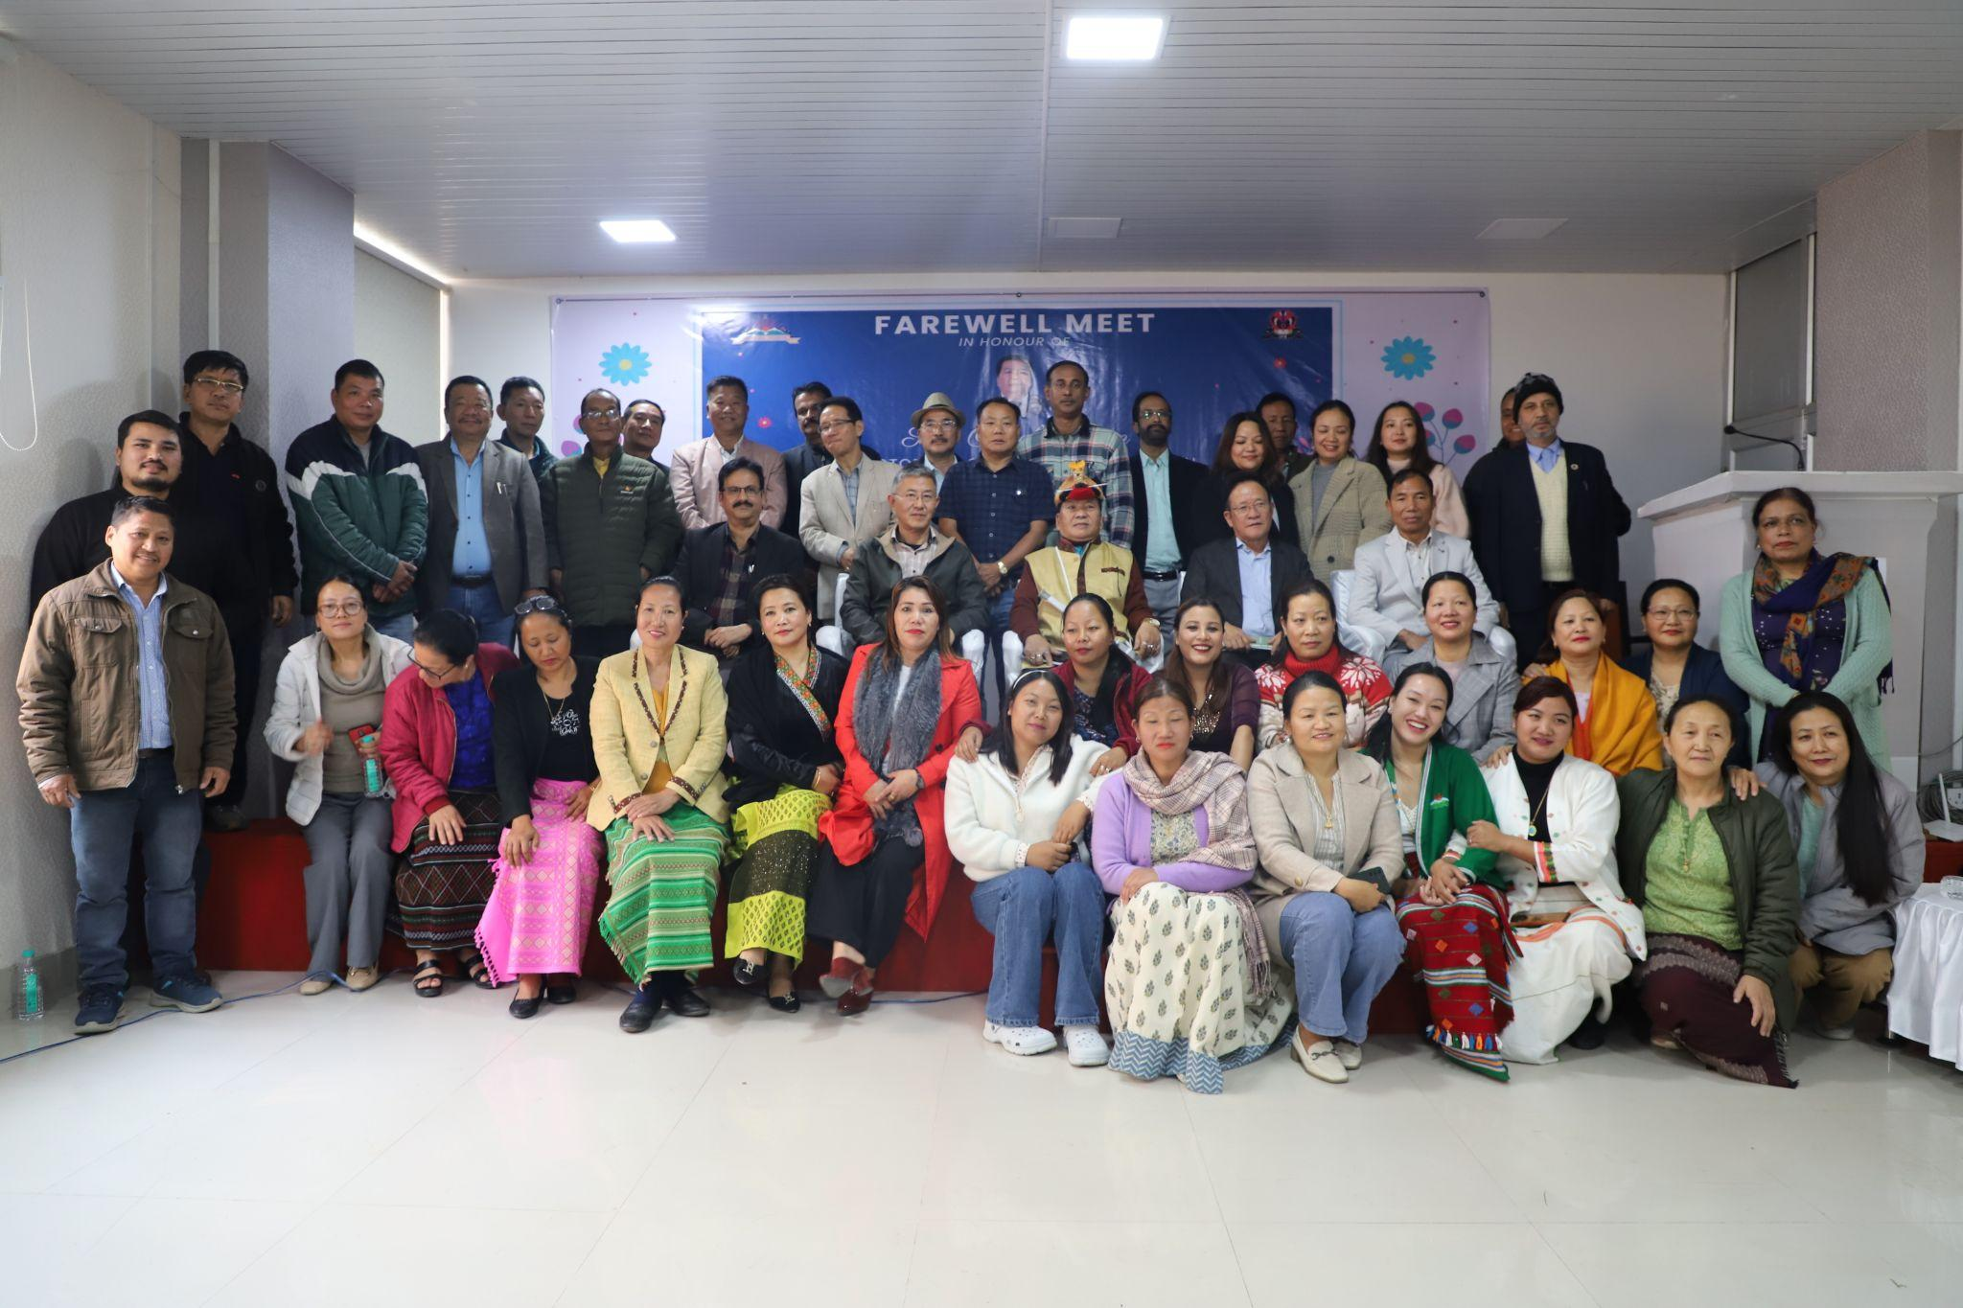
Naharlagun, Jan 31: The Department of Information and Public Relations (IPR) marked a significant milestone today with the inauguration of its Crèche facility, inaugurated by Nyali Ete, Secretary (IPR). The crèche is designed to provide daycare services for the children of department employees, in line with the Maternity Benefit Act, which mandates such facilities in Indian government offices with 50 or more employees.
The department also bid a heartfelt farewell to its Director, Onyok Pertin, who retired after 33 years of service to the state government. While congratulating the department on launching the crèche, Ete commended Pertin for introducing new initiatives during his tenure. He encouraged him to continue his involvement in social work, emphasizing that his contributions to society should extend beyond his government service. Ete also lauded Pertin’s work ethic and acknowledged his successful career.
Pertin began his journey with the department in 1992 as DIPRO, Anini, and went on to serve in Aalo, Changlang, Daporijo, Pasighat, and Yingkiong. He was transferred to the Directorate in 2016, where he was promoted to Deputy Director before assuming the role of Director in 2023.
Following Pertin’s retirement, Gijum Tali has been appointed as the new Director of the department.
