GOVERNOR’S SECRETARIAT
ARUNACHAL PRADESH
ITANAGAR

Press Communiqué
Dated Jan 31st, 2025

Jarken Gamlin (CIC) Major General (Rtd) attended the Arunachal Yuva Samanvay 4.0 2025 at Jirdin
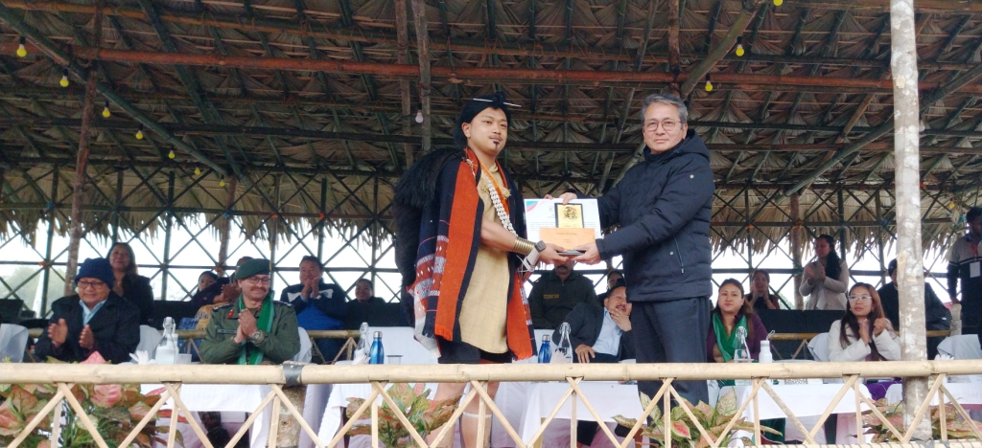
Kombo Jirdin the 31^{sh} January 2025: Sri Jarken Gamlin (Major General Retired) Chief Information Commissioner Govt of Arunachal Pradesh and Md Shahid Ahmad (Brigadier) graced the Arunachal Yuva Samanvay(AYS) 4.0 valedictory function as Chief Guest and Guest of Honour at Kombo Jirdin along with Sri Kento Jini Hon'ble Minister Law, Legislative & Justice, Sports & Youth Affairs, SJETA GoAP and Ms Mamu Hage DC West Siang.
Sri Ramesh Linggi Director Sports and Youth Affairs welcome the dignitaries, delegates from various tribes, publics etc. He highlighted the objective of conducting Arunachal Yuva Samanvay.
Sri Kento Jini Hon Minister Law, Legislative & Justice, Sports & Youth Affairs, SJETA in his speech urged the youths to be the torch bearer of the society and also informed them to grab the facilities of sports, provided by the Govt. for the sports meritorious person the state government is providing many facilities. He urged the youths of the state to excel in sports and academic career.
He informed the AYS 5.0 will be organised in the coming year also. He further said that due to the bad inclement weather the Honourable Governor of AP have to cancelled the AYS as a Chief Guest and conveyed his messages to the delegates and participants.
Md Shahid Ahmad (Brig) also spoke on the occasion.
Sri Jarken Gamlin as a Chief Guest urged the participant youths of the state to excellent in the study. And advised them to focused on study. The future of the society is depend on the youths of today. Education is the backbone of every society. He said our state is unity in diversity. He also appealed the youths to work for the upliftment of the state and society.
The Chief Guest, Guest of Honour and Minister gave away the prizes to the winners of various events.
The four days AYS was organised by department of Sports and Youth Affairs Govt of Arunachal Pradesh in collaboration with District administration led by Ms Mamu Hage(IAS) DC West Siang and Local organizing Committee of Kombo Jirdin village. Sri Momar Lollen ZPM Kombo-Jirdin coordinated with the local organizers and other stake holders.
Sri Tumto Loyi(DSO) Aalo thanks all the participants for smooth conducting of the youth programme.
The valedictory function was attended by Mamu Hage (IAS) DC West Siang, Sri Doi Ado Ex Minister, HoD's, Officers, Panchayat Leaders, Publics' , Cultural teams, Delegates from various tribes of Arunachal Pradesh.
