GOVERNOR’S SECRETARIAT
ARUNACHAL PRADESH
ITANAGAR

Press Communiqué
Dated Jan 31st, 2025

No Politics Should Drive Scheme Distribution: Wangsu

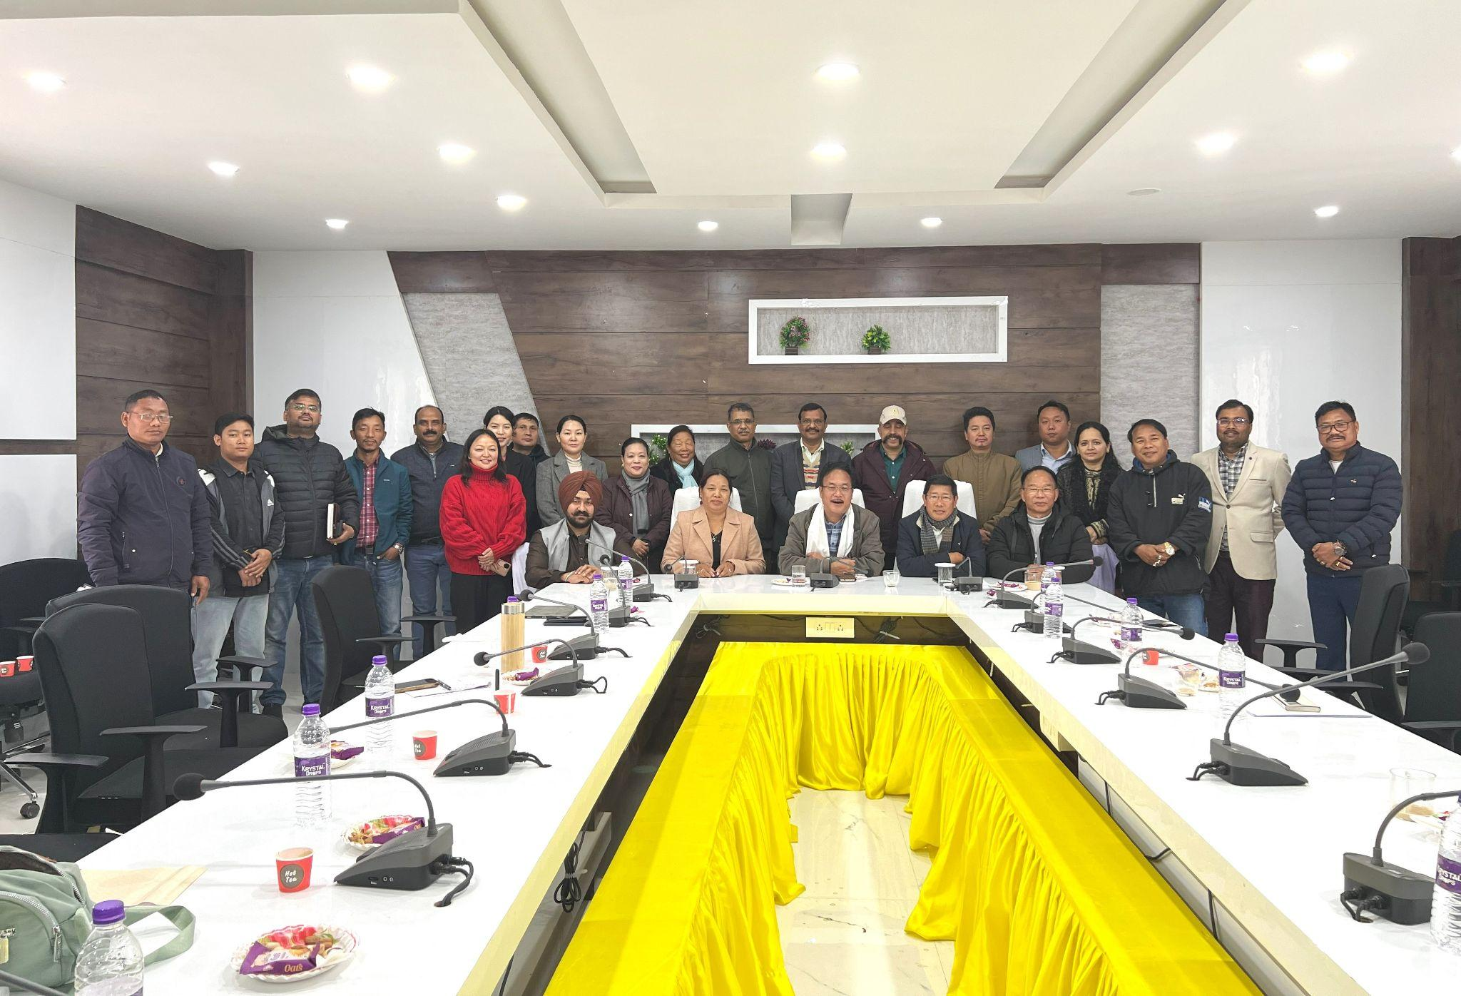
KHONSA, Jan 31: Arunachal Pradesh Agriculture Minister Gabriel D. Wangsu, during his first visit to Tirap district since assuming office, emphasized the need for a transparent and merit-based distribution of government schemes, asserting that political influence should not dictate beneficiary selection.
Chairing a comprehensive review meeting in Khonsa today, Wangsu—who oversees multiple portfolios including Horticulture, Animal Husbandry & Veterinary, Fisheries, Legal Metrology & Consumer Affairs, and Food & Civil Supply—was briefed by district department heads on ongoing projects and their financial status.
"Scheme benefits should be allocated based on genuine need, without political bias or personal connections," Wangsu stated while addressing challenges in initiatives like Atma Nirbhar. He assured officials that funding constraints would not hinder implementation and encouraged them to work diligently for the state's welfare, promising to oversee their career growth, promotions, and Recruitment Rules (RR) issues.
Expressing concern over unauthorized plant and cattle sales by private dealers, Wangsu highlighted the importance of safeguarding farmers' interests. He also introduced new initiatives such as ‘Catch Them Young’ and ‘Krishi Kendra’, aimed at strengthening the agricultural sector.
Supporting Wangsu’s stance, local legislators Wanglam Sawin (Khonsa East) and Chakat Aboh (Khonsa West), who also serves as Adviser to HM-Transport, condemned the practice of allocating multiple loans to single families due to political favoritism. They stressed the crucial role of the agriculture department in combating food scarcity in Tirap and Longding districts. Sawin particularly underscored the need for rigorous departmental oversight beyond just geo-tagging to ensure effective scheme implementation.
During his visit, Wangsu inspected key agricultural facilities, including the Horticulture Nursery Farm and Cattle Farm at CK Road. He instructed officials to procure large cardamom seeds exclusively from registered suppliers and urged the expansion of cattle farm infrastructure.
The review meeting was attended by senior district officials, including the Deputy Commissioner of Tirap and representatives from various agricultural departments. Wangsu assured that he would conduct regular follow-up visits to monitor progress and ensure effective implementation of development projects in the district.
