GOVERNOR’S SECRETARIAT
ARUNACHAL PRADESH
ITANAGAR

Press Communiqué
Dated Jan 31st, 2025

4th DLMC MEETING HELD

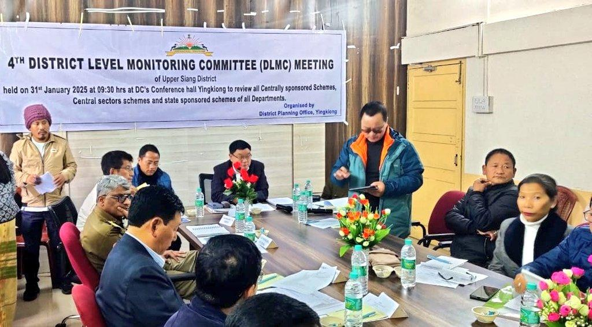
Yingkiong 31st Jan’2025: The 4th District Level Monitoring Committee (DLMC) of Upper Siang was held under the chairmanship of Deputy Commissioner Shri Talo Jerang at DC office conference hall here at Yingkiong today to review the physical and financial achievement of various ongoing projects of Central and State Sponsored schemes implemented by various departments in the district.
The meeting was attended by Superintendent of Police, Admin officers, all DLMC members, CO 5 Dogra Regiment, OC 761 BRTF and Lead Bank Manager.
While reviewing the progress reports of various Departments, DC Talo Jerang stressed upon that all line must ensure that all the Govt schemes should be completed on time and maintain quality of work.
The DC also urged the Lead Bank Manager to coordinate with concerned departments and ensure that applications of beneficiaries of various Govt schemes are taken up on priority basis and any shortcomings of documents than it should be immediately brought to the notice of department so that nothing remains pending for long. He also asked LDM to update the status of applicants in various banks.
During the meeting, CO 05 Dogra Regiment Col M. Shaw also spoke and gave presentation on various Civic action activities carried out by the Indian Army at border village –Gelling and Tuting . He also pointed out that Tuting Sub- Division has huge potential for adventure tourism development and informed that Indian Army is taking up initiative to boost up tourism activity in organized manner to enhance local economy and generates employment opportunities for local people.
Meanwhile various Dept of PWD, RWD, Hydro Power, PHED, Power, UD and Housing, WRD, RD, Agriculture, Horticulture, Education, ICDS, Fisheries, Industries, Textile and Handicrafts, APEDA, ArSLM gave power point presentation on status of CSS, SSS implemented by them.

