GOVERNOR’S SECRETARIAT
ARUNACHAL PRADESH
ITANAGAR

Press Communiqué
Dated Jan 30th, 2025

Curtain Raiser of Arunachal Film Festival 2024
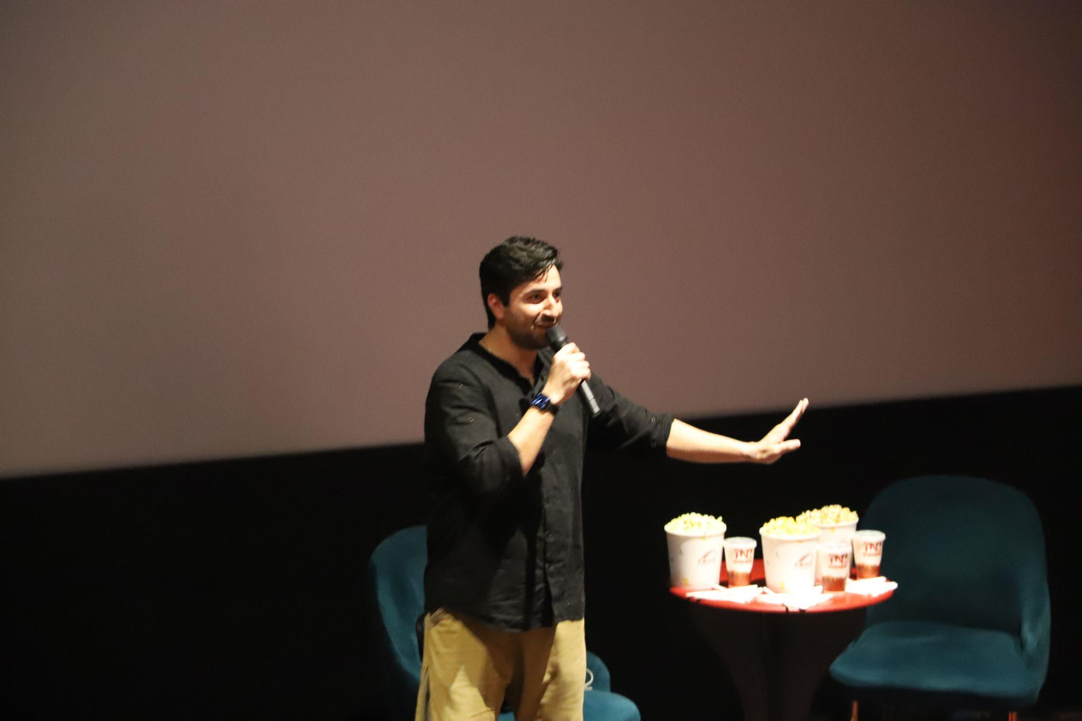
Itanagar, Jan 30 – The much-awaited Arunachal Film Festival 2024 kicked off with a grand curtain-raiser, marking the beginning of a celebration of cinematic excellence. The opening event featured the screening of Zero Se Restart, a behind-the-scenes documentary on the making of the acclaimed film 12th Fail.
Following the screening, Jaskunwar Kohli, the director of the documentary and one of the screenwriters of 12th Fail alongside Vidhu Vinod Chopra, addressed the audience, sharing insights into the filmmaking process.
The event also included an engaging masterclass on screenplay writing by Kohli himself. Industry experts contributed to the session, offering valuable lessons on storytelling, structure, and character development, providing aspiring filmmakers and cinephiles with key insights into crafting compelling narratives.
The Arunachal Film Festival 2024 aims to promote regional and national cinema, provide a platform for emerging filmmakers, and encourage creative discussions. The festival will feature a diverse lineup of films, panel discussions, and workshops in the coming days.
For the latest updates and the complete festival schedule, follow the official Facebook and Instagram pages of Arunachal Film Festival 2024-25.
