GOVERNOR’S SECRETARIAT
ARUNACHAL PRADESH
ITANAGAR

Press Communiqué
Dated Jan 30th, 2025

Teacher Training Workshop Held at SFS College, Aalo

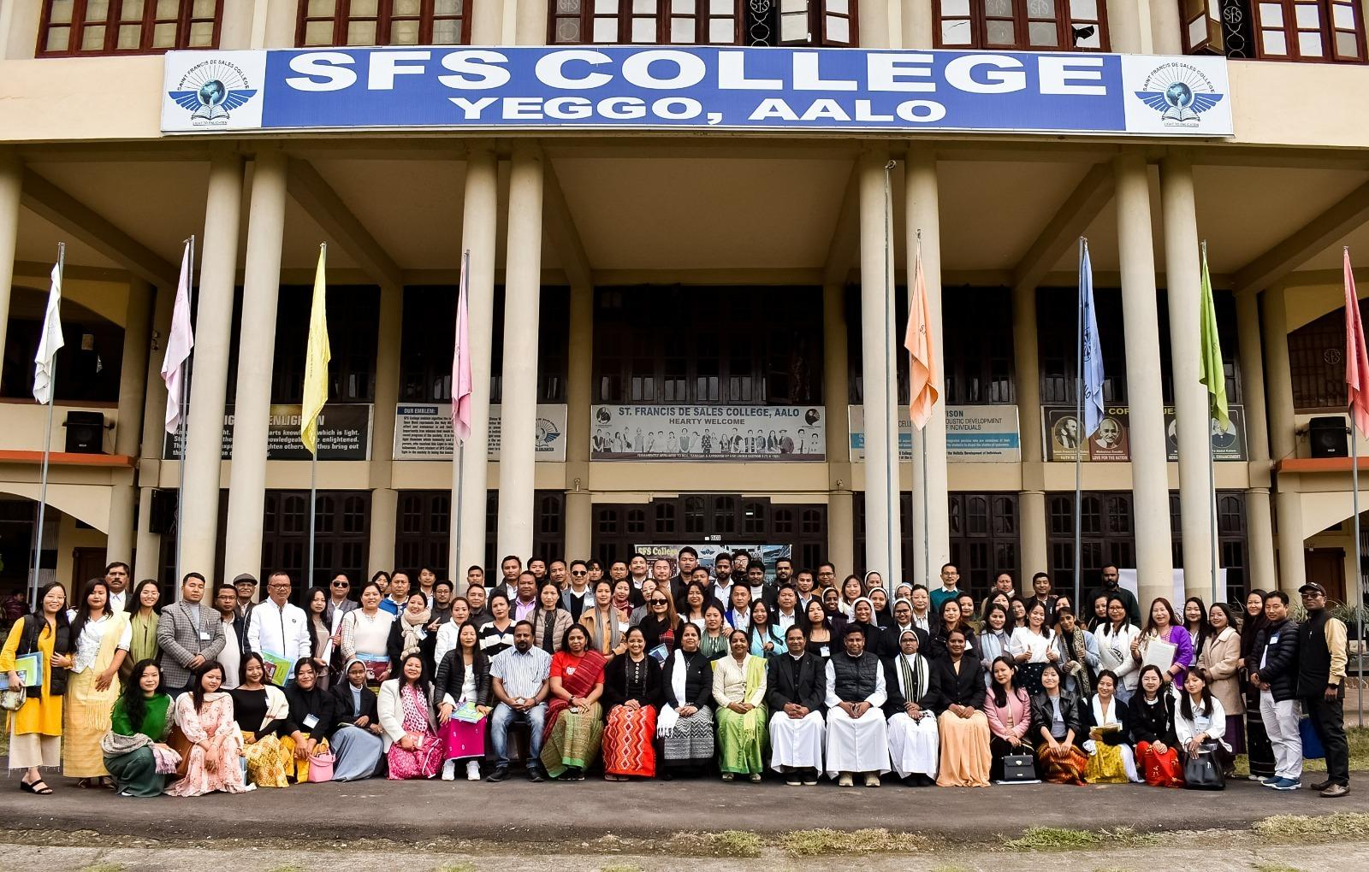
The IQAC, SFS College, Aalo, organized a three-day Teacher Training Workshop for Teachers private and Govt schools of West Siang and neighboring districts in Arunachal Pradesh at SFS College, Aalo from January 27 to 29, 2025. It was an extension activity of the College. The workshop was the outcome of successful collaboration among the College, the Education department of West Siang District and ASHA foundation, Bangalore. A total of six trainers from Bangalore and Pune, belonging to ASHA Foundation, Bangalore guided the 130 participants from 35 schools. SFS College Aalo initiated and organized the programme for the general good. The program enhanced teaching skills and promoted professional development among educators. It was hailed as ‘Excellent’ by all concerned for the noble objective, meticulous sessions, relevant contents, joyful hospitality and delicious dishes. The program was aimed to enhance teaching skills and promote professional development among educators.
The event was inaugurated on January 27, by Shri Tumme Amo, IPS, DIGP, APP Govt. of Arunachal Pradesh, as the Chief Guest. In his address, Shri Amo emphasized the critical role of teachers in shaping the future of society and urged them to adopt innovative teaching techniques to meet the changing needs of students in a dynamic world.
The training sessions covered a broad spectrum of topics, including innovative teaching methodologies, effective classroom management, technology integration in education, strategies for creating engaging and impactful learning experiences, Team building, Communication skills, Adolescent Challenges, the needs of Youth, Curriculum overviews, Practicum Planning Lessons, character versus personality, the importance of self-assessment & honesty, HIV/AIDS, Bullying and Body shaming, and Social media and Mental health. The program focused on empowering teachers to embrace modern practices that make education more effective and enjoyable for students.
The sessions were conducted by members of the ASHA Foundation, that include Dr. Glory Alexander (Founder/Director of ASHA Foundation), Dr. Biju Sabastain, Mrs. Tarini Willison, Mrs. Maya Singh, Mrs. Juanita John, and Mrs. Nina Amrita. Their expertise and insights greatly contributed to the success of the training, equipping teachers with valuable knowledge and practical strategies.
This initiative highlights SFS College's commitment to contributing to the educational development of the region. By organizing such a program, the college underscores the importance of equipping teachers with the necessary skills to face contemporary classroom challenges and enhance the overall quality of education in the district.
The collaboration with the ASHA Foundation further reinforced the value of partnerships in driving meaningful change in the education sector. The program's success reflects the dedication of both the organizers and participants to fostering a culture of continuous learning and improvement in teaching practices.
A total of 133 participants from 35 schools across six districts—Siang, West Siang, East Siang, Shi Yomi, Upper Siang, and Leparada were attended the program.

