GOVERNOR’S SECRETARIAT
ARUNACHAL PRADESH
ITANAGAR

Press Communiqué
Dated Jan 30th, 2025

Four-member Maharashtra Public Service Commission team calls on the Governor

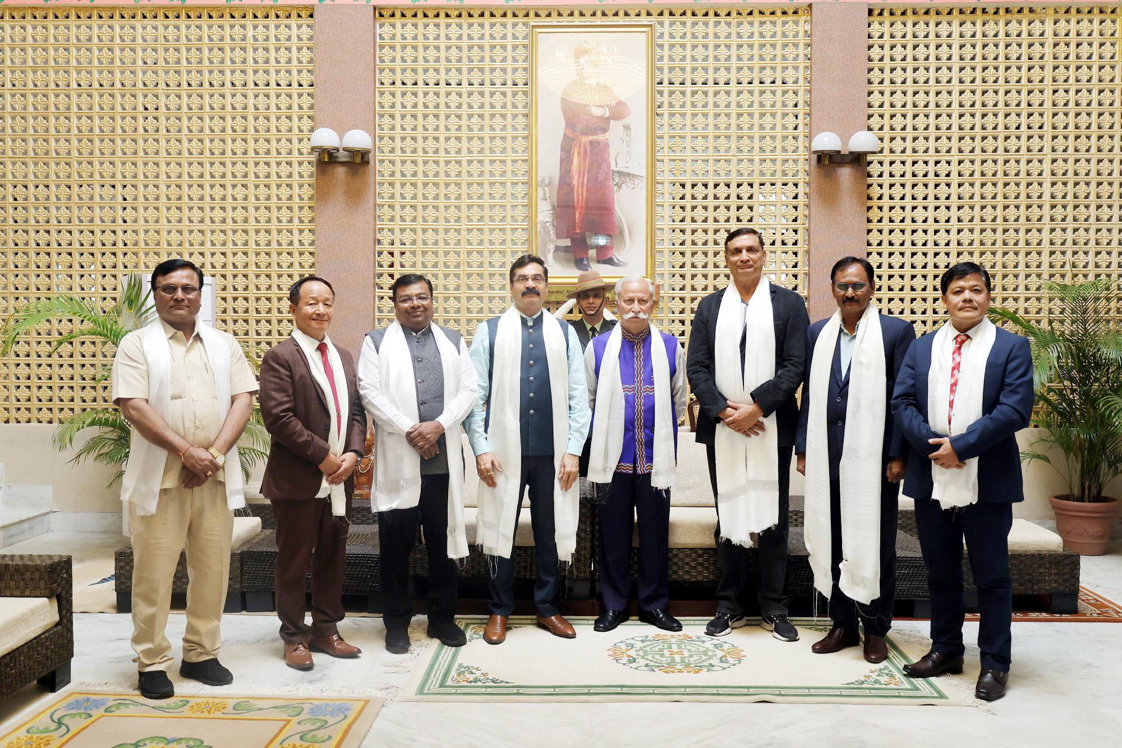
Four-member Maharashtra Public Service Commission team, accompanied by the Chairman, Arunachal Pradesh Public Service Commission Prof. (Dr.) Pradip Lingfa and member Col Koj Tari (Retd) called on the Governor of Arunachal Pradesh Lt. General KT Parnaik, PVSM, UYSM, YSM (Retd.) at Raj Bhavan, Itanagar on 30th January 2025. The MPSC Team, including Dr. Devanand Shinde, Dr. Satish Deshpande, Dr. Abhay Wagh and Dr. Dilip Pandharpatte is on a weeklong study tour to share good practices of the State Public Service Commission.
The Governor emphasized that merit must be the sole criterion for recommendations made by the Public Service Commission. He underscored that impartial and independent decision-making is crucial in fostering a secure, progressive, and developed society.
The Governor urged the members of the Public Service Commission of Arunachal Pradesh and Maharashtra, to ensure that the most capable individuals are recommended and entrusted with leadership roles by them. He stated that as India advances towards realizing the Viksit Bharat@2047 vision of Hon’ble Prime Minister Shri Narendra Modi, it is the duty of every responsible citizen, including Public Service Commission members, to uphold justice and equity in all spheres of life.
The Governor also highlighted Arunachal Pradesh's developmental progress and the significant contributions of its people in governance and administration. He stressed that through the selection of highly qualified and competent candidates, the Public Service Commission can drive meaningful and lasting positive change.
