GOVERNOR’S SECRETARIAT
ARUNACHAL PRADESH
ITANAGAR

Press Communiqué
Dated Jan 28th, 2025

Deputy Chief Minister Chowna Mein Inaugurates the 4th Edition of Arunachal YuvaSamanvay in Aalo

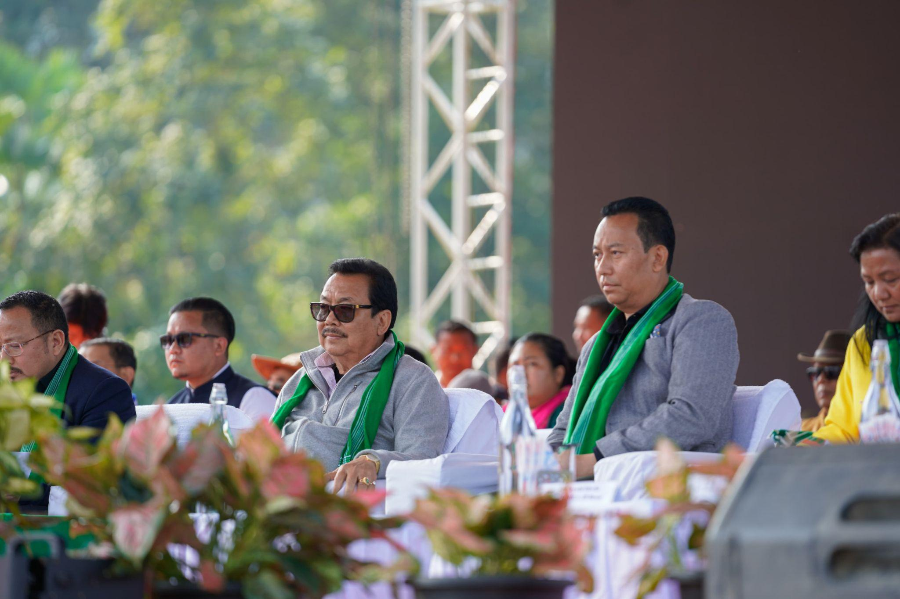

AALO, January 28: Deputy Chief Minister Chowna Mein inaugurated the 4th edition of Arunachal Yuva Samanvay, a flagship event celebrating the youth and cultural diversity of the state, at Kombo Jirdin Village near Aalo today. With the theme "Youth for Satat Vikas", the event provides a platform for the youth to unite, engage, learn, and empower themselves.
This vibrant celebration, representing all 26 major tribes of Arunachal Pradesh, seamlessly blends traditional heritage with modern aspirations. Designed to empower the youth, the event also aims to promote national integrity and showcase the state’s rich cultural legacy.
Addressing the gathering, Mein highlighted the vital role of Arunachal’s youth in shaping the state’s future. "Arunachal Pradesh is blessed with immense talent and a unique cultural heritage," he said. "Our youth are the future leaders, innovators, artists, and entrepreneurs. It is our collective responsibility to nurture their potential and empower them to propel our state to new heights." He further emphasized that a "Viksit Arunachal" cannot be envisioned without the active participation of its youth.
The theme of this year’s event focuses on fostering unity in diversity, encouraging youth participation in cultural performances, exhibitions, and intellectual discussions. With 750 participants showcasing their talents, the event stands as a true celebration of Arunachal’s vibrant culture and the potential of its youth.
Highlighting ongoing government initiatives for youth development, Mein reiterated the declaration of 2024–25 as the “Year of Youth” by the government. This initiative aims to channel the energy and enthusiasm of young people toward the state’s growth and progress. Several programs have been launched under this initiative, including:
- Arunachal Pradesh Scholarship for Academic Excellence
- Youth Desks in Kolkata, Guwahati, and Delhi
- Annual Rozgaar Melas in various districts
- Youth Parliaments and leadership training programs
- State funding of up to 75% for Commercial Pilot License and Merchant Navy Training
- Development of sports infrastructure, such as a 25,000+ capacity FIFA-standard football stadium in Itanagar
- Establishment of Youth Resource Centers and life skills sessions for students
Mein also commended the Department of Sports & Youth Affairs for successfully organizing Arunachal Yuva Samanvay over the years, noting consistent improvements with each edition.
The event promises to be a powerful platform for the state’s youth, fostering progress, unity, and cultural pride. Over the next few days, it will continue to showcase Arunachal Pradesh’s diverse cultural expressions, marking a significant step toward empowering its future leaders and creators.
Minister of Sports & Youth Affairs, Kento Jini, shared that this year’s event was held in Kombo Jirdin to allow youth from across the state to explore village life and immerse themselves in the Galo tribe's local culture. He urged the youth to avoid substance abuse and noted that the sale and use of alcohol and tobacco products are banned at the event venue.
Earlier in the day, the Deputy Chief Minister also inaugurated a Double Court Badminton Hall at Hisam Colony, Aalo. The land for the court was donated by Gamde Ete Gamlin. Mein assured ₹2 crore in funding for constructing a gallery and additional courts with modern amenities at the Taken Riba DBA Indoor Badminton Stadium, Aalo.
The programs were attended by MLAs Topin Ete and Nyabi Jini Dirchi, Former Minister Doi Ado, Sports & Youth Affairs Secretary Abu Tayeng, DC West Siang Hage Mamu, Director (Youth Affairs) Ramesh Linggi, Heads of Departments (HODs), public leaders, Goan Buras, and community members.
