GOVERNOR’S SECRETARIAT
ARUNACHAL PRADESH
ITANAGAR

Press Communiqué
Dated Jan 28th, 2025

District Police Yingkiong organised Anti-Drug awareness programme at VKV School Yingkiong

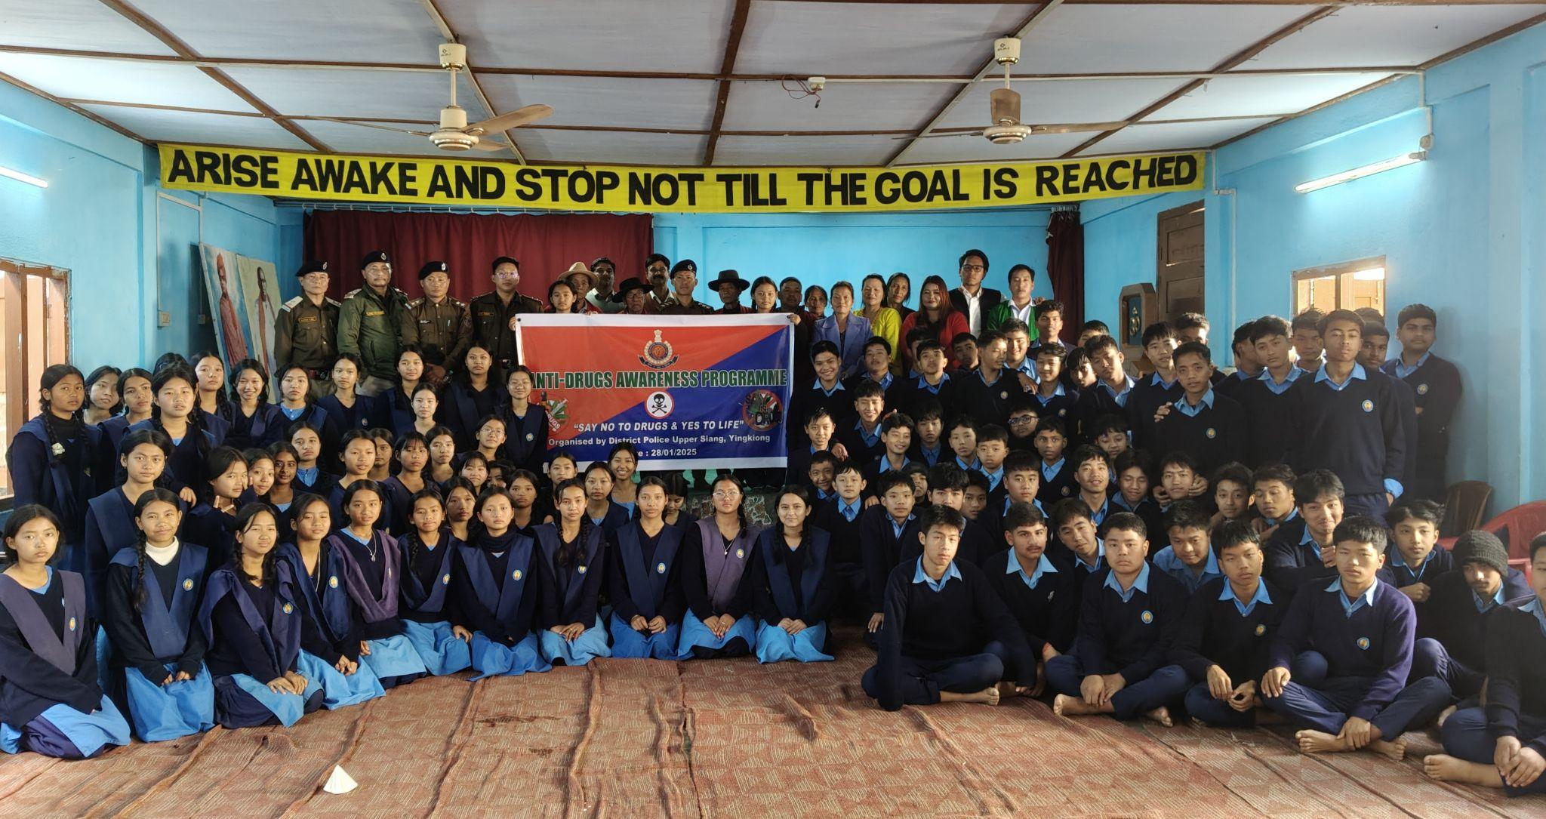

Yingkiong Jan 28’ 2025: In a crusade against drug abuse, the District Police, Upper Siang, Yingkiong conducted an Anti- Drug Awareness Programme at VKV School, Yingkiong with the aim to educate and raise awareness on drug abuse and its associated health hazards.
The Resource person on the occasion SI Police Station, Yingkiong Sri Kipa Robin gave a presentation on the anti -drug awareness campaign and emphasised on sustained effort from all stakeholders to effectively fight against it. He also advised students to stay away from drugs and engaged in physical activities like sports to remain active and healthy. A short film 'ROSHNI' Crusade against Drug Abuse made by Capital Police and audio -Visual short clippings of movies on drugs were also shown to raise awareness on the menace of drugs.
Meanwhile, Upper Siang DySP Sri Gocham Sakter also gave a presentation on Prevention of Child From Sexual Offences( POCSO) Act 2012 and inform the students about it's key points and underlying legal provision under the Act to protect children from sexual abuse and exploitation. He also emphasised on recognising inappropriate behaviour and reporting it immediately to family member, police or CWC and elucidated on stringent punishment under the Act.
SI Sri Ojing Moyong also shared his experience of dealing with drug abuse cases and advised the students to respect their parents and elders and listen to their advices to become a better person in future.
The Upper Siang Child Welfare Committee Advocate Panyang also spoke and advised the students to always remain cautious and stay away from use of any form of drugs.
President All Upper Siang GB Welfare Association Shri Akkong Libang who also attended the programme and spoke on how a drugs can jeopardise a healthy society. He advised the students to choose healthy life and never give in to drugs and other bad habits. Advocating concerted effort from all sections of the society to fight against menace of drugs in Upper Siang District he also requested the Police dept to share identity of habitual drug peddlers to GBs so that it can be circulated among GBs to prevent them from ruining lives of young generations.
HGB Sri Tanyong Lipir who also spoke on the occasion advised the students to refrain from indulging in any unwanted activities and focus on their studies to become responsible citizen.
ABK Youth President Nong Nangu also spoke and appreciated Distt police for conducting such awareness programme for students and requested all students to share their knowledge among their families and friends gained through such a programme to remain alert and informed against harmful effects of drugs. A concerned women mother and a representative from SHGs group also spoke and appreciated the District Police and expressed their support in creating awareness on illicit drugs and child protection act to ensure safer future for all children.
Alongwith CBOs, SHGs members, GBs, Police Officers, staff, Principal Sumithran, Vice Principal and students from Class 10 to 8 attended the programme.
