GOVERNOR’S SECRETARIAT
ARUNACHAL PRADESH
ITANAGAR

Press Communiqué
Dated Jan 25th, 2025
National Voters’ Day Observed at Governor Secretariat, Itanagar
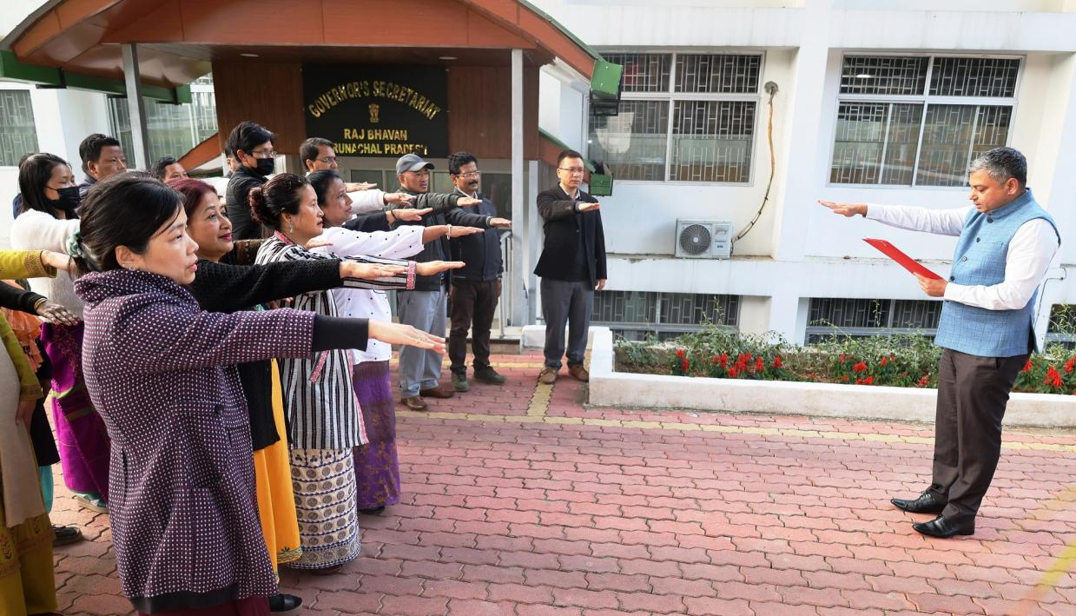

Along with the rest of the nation, the Governor's Secretariat at Raj Bhavan, Itanagar, celebrated the 15th National Voters’ Day under the theme ‘Nothing Like Voting, I Vote for Sure’. The event witnessed enthusiastic participation from the officers and staff of the Secretariat.
The Secretary to the Governor, Shri Darade Sharad Bhaskar, administered the National Voters’ Day pledge to the officials. The pledge reaffirmed their commitment to upholding India's democratic traditions and ensuring free, fair, and peaceful elections.
Speaking at the event, Shri Darade emphasized the critical role of every vote in strengthening the country's democratic framework. He stated that voting is not only a fundamental right but also a tribute to the essence of democracy, underscoring the power voters hold in shaping the nation’s future.
The observance served as a reminder of the responsibility and power of voters in building a vibrant and inclusive democracy.

