GOVERNOR’S SECRETARIAT
ARUNACHAL PRADESH
ITANAGAR

Press Communiqué
Dated Jan 19th, 2025
First Adi- Apatani Summit inks joint declaration
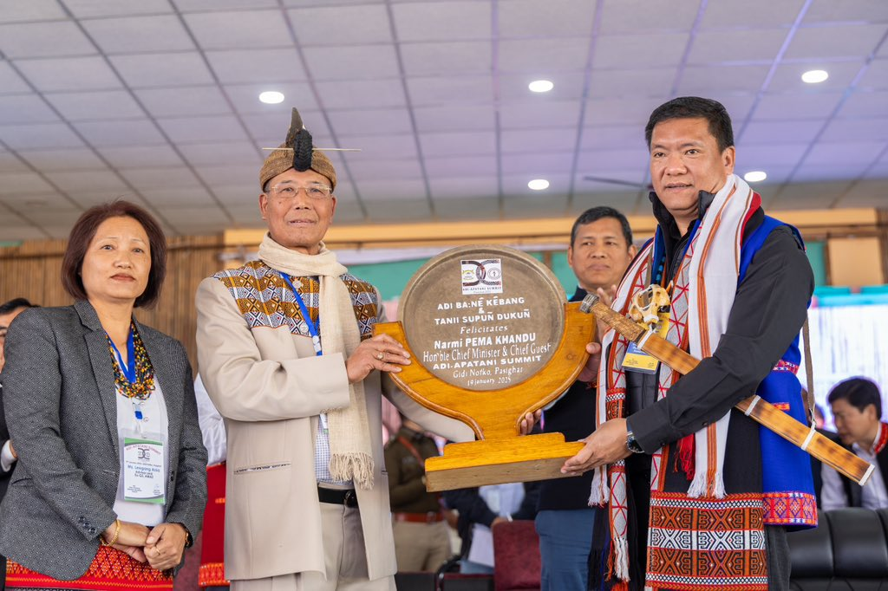

PASIGHAT, January 19, 2025: The first Adi-Apatani Summit was successfully organized at Gidi Notko, Pasighat, marking a historic moment of unity and collaboration. The event witnessed the signing of a Joint Declaration led by the apex bodies of the two communities—the Adi Bane Kebang (ABK) and Tanii Supun Dukun (TSD)—to foster and strengthen age-old community bonds, promote cultural exchanges, and enhance mutual cooperation for building a progressive society.
Chief Minister’s Address The summit, held in the presence of Chief Minister Shri Pema Khandu as the Chief Guest and Home Minister Shri Mama Natung as the Guest of Honour, was celebrated as a significant step toward community harmony. Other dignitaries present included Minister for Rural Development and Panchayati Raj Ojing Tasing, Lok Sabha MP Tapir Gao, President of the Mishmi Welfare Society Matheim Linggi, MLAs Hage Appa, Alo Libang, Tapi Darang, Punyo Apum, Oni Panyang, and former ministers Tage Taki, Padi Richo, and Nani Ribia, among others.
Key Remarks
- Home Minister Mama Natung praised the Adi-Apatani Summit as a model initiative, emphasizing its alignment with the vision of "Team Arunachal" and "Ek Bharat Shreshtha Bharat." He encouraged other community-based organizations to emulate such efforts and highlighted the importance of collective action against drug abuse to protect future generations.
- Lok Sabha MP Tapir Gao applauded the event, noting that implementing the Summit Declaration would have a transformative impact at the grassroots level.
- Minister Ojing Tasing emphasized the shared knowledge and mutual learning opportunities between the two communities.
- President of the Mishmi Welfare Society, Matheim Linggi, called the initiative an inspiration for building a Pan-Arunachal identity based on brotherhood and amity.
- MLA Hage Appa referred to the summit as a golden milestone, urging the youth to carry forward its legacy.
Summit Activities The summit began with a welcome address by Chairman of the Adi-Apatani Summit Organizing Committee, Oki Dai. The highlights included the flag-hoisting ceremony by the Presidents of ABK and TSD, cultural performances, unity dances, and a community lunch. President H.K. Shalla (TSD) and President Tadum Libang (ABK) presented the historical context and significance of the Joint Declaration, which underscores collaboration for a progressive future.
Commitment to Unity The summit’s Joint Declaration reinforced the shared vision of fostering goodwill, preserving cultural heritage, and working together to achieve holistic development. It was a testament to the enduring bond between the Adi and Apatani communities and a step toward a united and progressive Arunachal Pradesh.
This historic occasion is expected to inspire similar initiatives across the state, promoting harmony and mutual understanding among diverse communities.

