GOVERNOR’S SECRETARIAT
ARUNACHAL PRADESH
ITANAGAR

Press Communiqué
Dated Jan 19th, 2025

Union Minister Smty. Sabitri Thakur Reviews Welfare Schemes and Developmental Projects in Upper Subansiri District

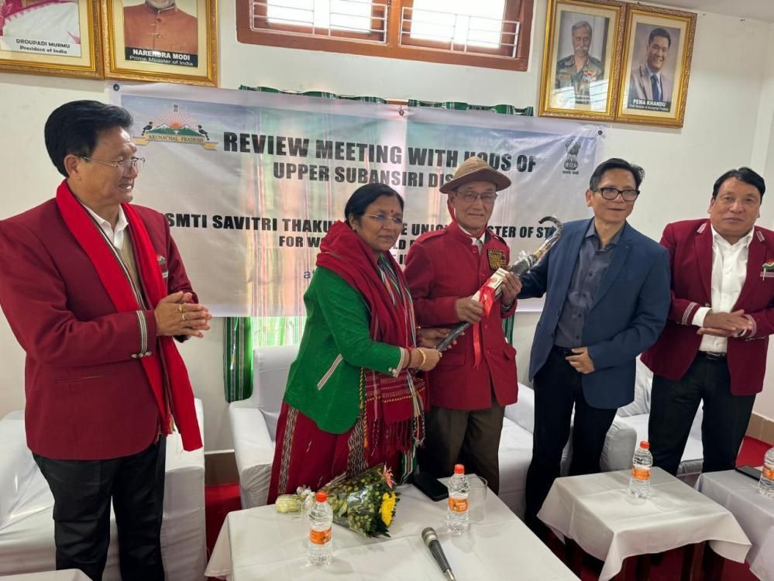

Daporijo, 19 January 2025: Union Minister of State for Child Development, Smty. Sabitri Thakur, conducted a two-day official visit to the Upper Subansiri District. She was accompanied by Ms. Namisha Jha, Private Secretary; Shri Deep Kumar, Additional Private Secretary; Nyato Dukam, Minister of Industry and Information & Public Relations, Government of Arunachal Pradesh; Daporijo MLA Taniya Soki; and Dumporijo MLA Rode Bui.
During her visit, the Union Minister chaired a review meeting with Heads of Departments (HoDs) to assess the progress of various central flagship programs, welfare schemes, and allied developmental initiatives in the district. She emphasized the importance of ensuring that welfare schemes and basic facilities reach every individual and household, stressing that no weaker section or individual should be left behind.
Smty. Thakur also highlighted the significance of preserving tribal culture and identity alongside developmental efforts. "Developmental works must go hand-in-hand with the protection and preservation of our rich tribal heritage and cultural identity," she remarked.
As part of her tour, the Union Minister visited the villages of Sikarijo, Digbak, and Belo, where she inspected works under the Mahatma Gandhi National Rural Employment Guarantee Act (MGNREGA) and the Pradhan Mantri Awas Yojana (PMAY). She expressed satisfaction with the progress and encouraged further efforts to meet the needs of the community.
Additionally, Smty. Thakur visited the One Stop Centre, the District Museum, and the Textile & Handicrafts Center in Daporijo to review their operations and assess their role in promoting local art and welfare.
Her visit underscores the Government of India's commitment to inclusive development and the preservation of cultural heritage in the northeastern region. The minister’s interactions and inspections have set a roadmap for enhanced implementation of welfare programs in Upper Subansiri District.

