GOVERNOR’S SECRETARIAT
ARUNACHAL PRADESH
ITANAGAR

Press Communiqué
Dated Jan 17th, 2025

GTGH performs maiden triple nerve block surgery

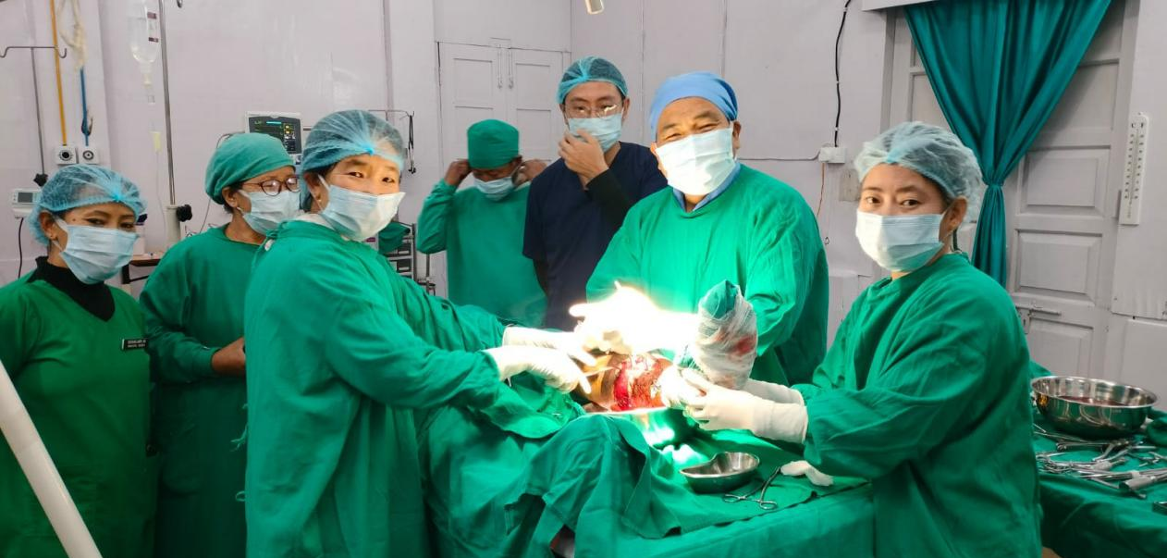

ZIRO, 17 Jan ‘25: A maiden triple nerve block surgery using ultra sound guided anesthesia was carried out at the Gyati Takka General Hospital (GTGH) here today.
A patient’s lower limb was successfully operated upon using ultra sound guided anesthesia for triple nerve blocks of femoral, saphenous and sciatic led by GTGH team of anesthetists Dr. Koj Jarbo, who is also the GTGH medical superintendant assisted by Drs. M. Muri and Subu Nobing. The surgical team was headed by senior orthopaedician Dr. Hage Taker and his team of nursing assistants.
The complicated surgery is also performed at TRIHMS, however the same was carried out for the first time at a District based hospital, informed Dr.Jarbo, who had been an anesthetist at TRIHMS prior to his posting to GTGH.
Also a clinical anesthetist, Dr.Jarbo informed ‘The ultra sound guided anesthesia surgery has many advantages over the conventional surgery using general anesthesia and spinal anesthesia. The chances of error and its consequences are almost reduced to nil. Further, it is much safer compared to the blind procedure followed during a conventional surgery and very convenient for all concerned including the patient and doctor’. Adding further, Dr. Jarbo said ‘such high-end procedures are now going to take place place on regular basis at GTGH and many complicated cases will be solved within GTGH campus using the services of experts and specialists even from outside the state. At the end of the day, we are trying our best to treat the patients within GTGH campus instead of referring them outside to TRIHMS or other hospitals for which we are prepared to go extra miles as in this case’, said Dr.Jarbo.
Senior orthopaedician Dr. Hage Taker said ‘In my career spanning more than two decades as an orthopaedician, this was the first complicated surgery which went seamlessly well due to use of sophisticated high end surgical process combined with the efficient team of doctors, anesthetists and nursing assistants of GTGH’, while adding, this was his first major surgery post New Year for which he was glad as all went well. The Gyati Takka General Hospital, one of the best District based hospital is equipped with the best of medical team of doctors and infrastructures. Recently the construction of hospital’s new block has been completed and scheduled to be inaugurated soon and upgraded to a zonal hospital.
