GOVERNOR’S SECRETARIAT
ARUNACHAL PRADESH
ITANAGAR

Press Communiqué
Dated Jan 17th, 2025

Pasighat police destroyed over 80 modified bike silencers
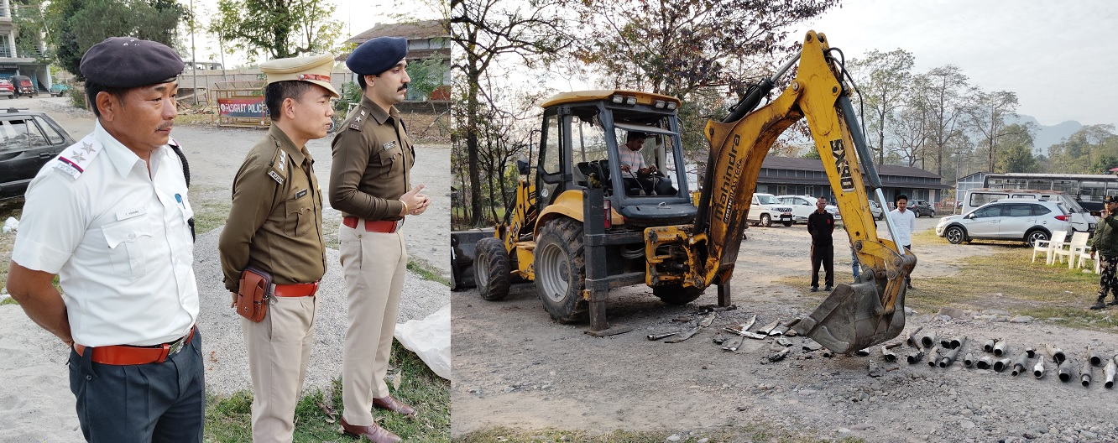

PASIGHAT, Jan 17: Pasighat Police seized about 80 illegally modified bike silencers leading to sound pollution and causing nuisance to the common public. The bike silencers were seized/dismantled as part of a special drive under ‘Road Safety Month’ campaign and were destroyed today using JCB at the Reserve Police Line (RPL) campus in presence of SP Pankaj Lamba, DSP Ayup Boko, traffic police officers and media-persons.

SP Lamba told reporters that seized modified silencers were found beyond the permissible decibel limits and in violation of traffic rules. Use of modified silencers is illegal and can result in fines and license suspension. It is directly related to the safety of children and senior citizens in particular and general public as a whole on road and we have a zero-tolerance policy regarding their safety.

Lamba stated that people replace the factory fitted exhaust system of their bike or modify the fitted unit which results in the exhaust system emitting a loud noise way above the prescribed decibel limit which pose a safety risk and increase the likelihood of accidents. During our “Road Safety Month 2025” campaign headed by the SP and police have fined numerous bikes and seized/dismantled more than 80 modified silencers so far and finally destroyed today using JCB, the SP added. He warned bike riders against the use of modified silencers and advised them not to alter the company provided silencers and further informed that appropriate legal action will also be taken against the individuals/dealers involved in the manufacturing and sale of modified silencers.

