GOVERNOR’S SECRETARIAT
ARUNACHAL PRADESH
ITANAGAR

Press Communiqué
Dated Jan 17th, 2025

CM Pema Khandu Urges Deputy Commissioners to Focus on Solutions and Drive Development at Sashakt Arunachal Conference
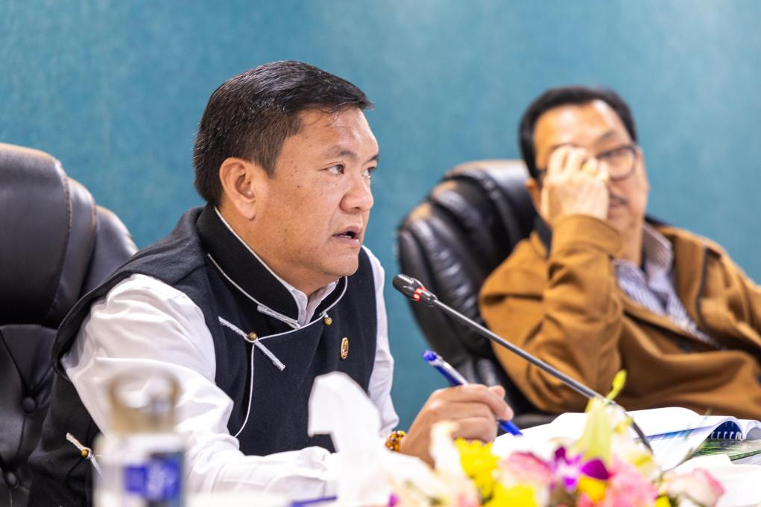

Chief Minister Pema Khandu, addressing the deputy commissioners from across the state today, asserted that shying away from problems is not the way forward but finding a solution to problems and moving ahead is the solution.
Giving his concluding remarks at the 2-day Sashakt Arunachal Conference of Deputy Commissioners here this evening, he said, “There will be problems faced by the deputy commissioners, yes. But we need to find solutions and move forward. It is said that we humans use at the most about 9-10% of our brains. Therefore, if we even utilize 40-50% of our brain, solutions will be there.”
Appreciating the DCs for their active participation in the conference, Khandu urged them to take cue from the ‘best practices’ presented by various DCs during the technical sessions and implement them in their respective districts. He assured that all the presentations made by respective DCs would be shared with all other DCs after the conference.
He said that each district will be measured in terms of their contribution to the state’s revenue collection henceforth.
Informing that the state’s revenue generation is witnessing a growing trend by each year, he advised the DCs to review their respective district’s contribution to it and if it’s not satisfactory, implement measures to make it satisfactory.
“We will soon share with each DC how much their district is contributing to the state exchequer and how much are the contribution of others. This will help you know where your district stands in terms of revenue generation and which sector needs your attention,” he said.
Khandu also informed that soon the DCs will be shared with a list of ‘action to be taken’ points for their respective districts.
“CMO will monitor the actions being taken by the districts as listed and their achievements,” he added.
For better coordination, Khandu said that each non-engineering department will be allotted one working department for all infrastructure development of that department. Giving an example, he cited that the Public Health Engineering department will undertake all construction, renovation or infrastructure development works of the Health department.
Advocating decentralization of power and planning through a bottom-up planning process, Khandu said that reform is in final stages of compilation and that once the reform is finalized, another round of conference with all the DCs will be held.
The ‘Reform’ in education department is also in the final stages and will be soon placed before the Cabinet, Khandu informed, and sought cooperation of the DCs to implement the reform in toto once it is circulated.
Talking about Cabinet meetings, he said that Cabinet meetings are held monthly and in line with the government’s ‘decentralization’ policy, these will be held across the state, out of Itanagar.
“To showcase our commitment to decentralize power and planning, we will start by holding the next Cabinet meeting at Nyapin in Kurung Kumey district,” he revealed.
Khandu advised the DCs to conduct brainstorming meetings at the district levels by January end on takeaways from the conference and prepare a roadmap for the district’s development. He informed that in February the Guardian Ministers and Mentor Secretaries will visit their allocated districts and hold review meetings with the DCs and HoDs.
He also asked the DCs to identify unused or defunct assets like polytechnics in their respective districts and put these to proper use.
The 2-day conference revolved around six thematic areas, each designed to address specific dimensions of governance and development. These included; Sundar Arunachal – Focusing on enhancing the state’s natural and cultural beauty, promoting eco-tourism, and preserving our unique heritage; Samridh Arunachal – Driving economic growth through sustainable use of resources, fostering entrepreneurship, and ensuring equitable wealth distribution; Shikshit Arunachal – Advancing education and skill development to empower our youth and create a knowledgeable society; Swasth Arunachal – Strengthening healthcare infrastructure and ensuring access to quality healthcare for every citizen; Surakshit Arunachal – Enhancing safety, security, and disaster resilience across all districts; and Swachch Arunachal – Promoting cleanliness, sanitation, and environmental sustainability for a healthier future.

