GOVERNOR’S SECRETARIAT
ARUNACHAL PRADESH
ITANAGAR

Press Communiqué
Dated Jan 15th, 2024

First meeting of the Arunachal Pradesh Cabinet for the year 2025, chaired by Honorable Chief Minister Pema Khandu
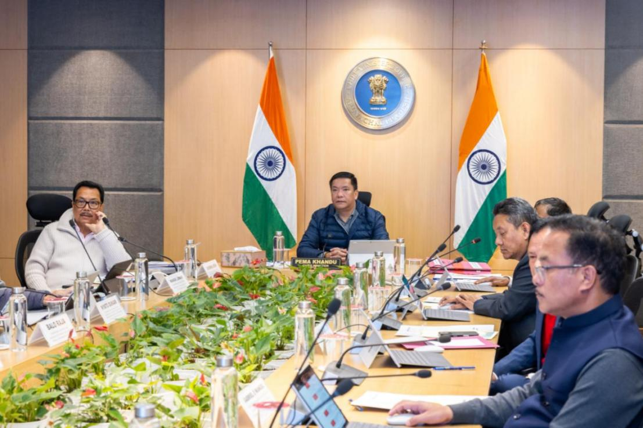

The first meeting of the Arunachal Pradesh Cabinet for the year 2025, chaired by Hon’ble Chief Minister Pema Khandu, was held today. The meeting marked a significant step toward strengthening infrastructure, governance, and citizen service delivery across the state.
The Cabinet decided to recommend to the Government of India the proposal to set up a 100-seat Medical College and a 420-bedded hospital at Namsai under the Aspirational District Programme. This project is planned under the Public-Private Partnership (PPP) model and aims to bridge the gap in healthcare services and medical education in the region. The total project cost is ₹375 crore.
In a major decision to enhance financial viability of large hydropower projects rejuvenated through MoAs with Central Public Sector Undertakings (CPSUs), the State Cabinet approved the grant of SGST reimbursement concessions for the Tato II Hydroelectric Project (700 MW) and the Kamala Hydroelectric Project (1,720 MW). The Tato II HEP, located on the Siyom River in the Shi Yomi district and the Kamala HEP, is located on the Kamala River in the Upper Subansiri district. Both these projects will be implemented in Joint Ventures between the State Government and the respective CPSUs, with the State Government holding 26% equity share in the Joint Venture.
These projects entail a cumulative investment of around ₹35,000 crore and are expected to generate close to ₹470 crore in free power and ₹79 crore Local Area Development Fund every year after commissioning. These 2 projects are part of the 13 stalled large HEPs rejuvenated by the State Government through the signing of MOAs with four CPSUs in 2023.
The two HEPs will generate significant employment and self-employment opportunities through infrastructure development and ancillary services, along with benefits to local communities through enhanced infrastructure, including roads, healthcare, and educational facilities, fostering long-term socioeconomic growth. The projects will upskill local workers, create a pool of skilled labor, and boost regional economic activity, contributing to Arunachal Pradesh’s development, as well as harnessing Arunachal Pradesh’s significant hydroelectric generation potential of 58,000 MW.
The State Cabinet also approved the policy on the Arunachal Pradesh Policy for Restoration of Terminated Large Hydropower Projects under Special Circumstances, 2025. This policy aims to revive terminated large hydropower projects that achieved substantial progress at the site. This will help facilitate a development-focused environment through timely project restoration and promote investments and employment opportunities, while enhancing the ease of doing business in the state.
In an effort to enhance administrative efficiency and optimize citizen service delivery, the State Cabinet also approved:
a. the upgradation of 20 JE (Civil) posts in the Department of Hydropower Development to 20 ASW (Civil) and AE (Civil) posts to l streamline the efficient functioning of the Department and ensure proper manning of positions at the divisional and district levels, and address issues ofstagnation and lack of career advancement opportunities for the incumbent officers
b. Creation of 36 posts in the Department of Land Management including 1 Group A Post, 15 Group B posts and 20 Group C posts to enhance operational capacity of the Department
c. 32 teaching and non-teaching posts were approved for the Government Engineering College, Tezu, to enhance its academic and administrative capacity, and provide new age-learning and skilling opportunities for students
The Cabinet also approved the creation of an Electrical Sub-Division at Chambang, along with manpower, to enhance power management in Kurung Kumey district, and sanctioned a new Public Works Department (PWD) Division at Koloriang and a Sub-Division at Damin to accelerate infrastructure development in the district.

