GOVERNOR’S SECRETARIAT
ARUNACHAL PRADESH
ITANAGAR

Press Communiqué
Dated Jan 15th, 2024

Best Electoral Practices State Award, 2024
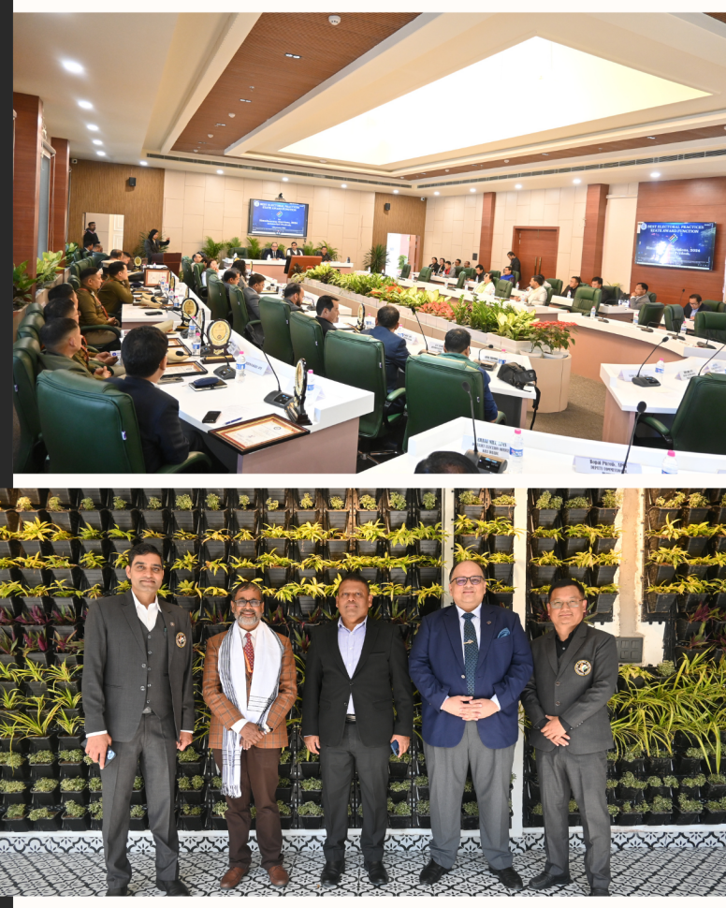

The Chief Electoral Officer, Arunachal Pradesh, organized a prestigious award ceremony on 15th January 2025 at Nirvachan Bhawan, Itanagar, to felicitate the Best Electoral Practices State Award recipients for the Simultaneous Election, 2024.
The event was graced by Shri Manish Kumar Gupta, IAS, Chief Secretary, Govt. of Arunachal Pradesh, as the Chief Guest, and Shri Anand Mohan, IPS, Director General of Police, as the Guest of Honour. The ceremony witnessed the presence of esteemed officials, including Commissioners, Secretaries, District Election Officers (DEOs), Deputy Commissioners (DCs), State Nodal Officers, and award recipients.

Award Presentation
Shri Manish Kumar Gupta, IAS, along with Shri Anand Mohan, IPS, and Shri Pawan Kumar Sain, Chief Electoral Officer, Arunachal Pradesh, conferred the Best Electoral Practices State Award to 12 District Election Officers-cum-Deputy Commissioners and 7 Superintendents of Police. The award included a Certificate, Memento, and a cash prize of Rs. 50,000/-, designated for SVEEP (Systematic Voters’ Education and Electoral Participation) activities.

List of Awardees
Sl. No. | Name & Designation | District | Award Category
1 | Shri Sachin Rana, IAS, DEO | East Kameng | Retrieval Plan
2 | Shri Bomken Basar, APPS, SP | Kurung Kumey | Preventive Policing
3 | Ms. Akriti Sagar, IAS, DEO | West Kameng | -
4 | Shri Kanki Darang, APCS, DEO | Tawang | Remote Area Election Management
5 | Shri Kamdam Sikom, APPS, SP | East Kameng | Community Policing
6 | Ms. Mamu Hage, IAS, DEO | West Siang | Election Management
7 | Ms. Ira Singhal, IAS | Tirap | -
8 | Shri C R Khampa, APCS, DEO | Namsai | Rationalization of Polling Stations
9 | Shri Sunny K Singh, IAS, DEO | Kra Daadi | Innovative Measures
10 | Shri Shasvat Saurabh, IAS, DEO | Lohit | Voter Education & Electoral Participation
11 | Shri Rujjum Rakshap, APCS, DEO | Lower Siang | Arms Deposition
12 | Dr. Sachin Kumar Singhal, IPS, SP | East Siang | -
13 | Shri Keni Bagra, APPS, SP | Lower Subansiri | -
14 | Shri Taru Gusar, IPS, SP | Papum Pare | Security & Nakas
15 | Shri Rohit Rajbir Singh, IPS, SP | ICR, Papum Pare | Electoral Literacy Clubs
16 | Smti Soumya Saurabh, IAS, DEO | Lower Dibang Valley | Electoral Management
17 | Shri H.P. Vivek, IAS | Lower Subansiri | -
18 | Ms. Vishakha Yadav, IAS, DEO | Kurung Kumey | Security Management
19 | Shri Dekio Gumja, APPS, SP | Longding | Accessible Elections

Launch of Electoral Publications
Shri Manish Kumar Gupta, IAS, Chief Secretary, also launched the Flow of Instruction Compendium and the Statistical Handbook for Simultaneous Elections 2024 in Arunachal Pradesh during the event.

Experience Sharing
Several awardees, including Ms. Mamu Hage, IAS (West Siang); Ms. Vishakha Yadav, IAS (Kurung Kumey); Smti Soumya Saurabh, IAS (Lower Dibang Valley); Shri Rohit Rajbir Singh, IPS (Itanagar); Shri Dekio Gumja, APPS (Longding); Dr. Sachin Singhal, IPS; and Ms. Bullo Mamu, IRS, shared their valuable experiences in conducting the Simultaneous Elections, 2024.

Student & Booth Level Officer Felicitation
Students from Kendriya Vidyalaya Naharlagun, Kendriya Vidyalaya Itanagar, and Vivekananda Kendriya Vidyalaya Chimpu were honored by Shri Ankur Garg, IAS, Commissioner, Govt. of Arunachal Pradesh, for their excellence in poster-making competitions. They received Certificates, Trophies, and Gifts.
Additionally, Shri Ankur Garg, IAS, presented the Best Booth Level Officer Award to the following individuals:
- Shri Chow Tee Chowpoo, PRT, Namsai
- Shri Tohua Misia, TGT, Khonsa
- Smti Same Mikhu, Gram Sevika (Jr), Roing
Each received a Certificate, Trophy, and a cash prize of Rs. 10,000/-.

Special Recognition
Ms. Marie Game, SVEEP State Transgender Icon, was also felicitated with a special gift.
The event concluded with a Vote of Thanks delivered by Shri Liken Koyu, APCS, Joint Chief Electoral Officer, Arunachal Pradesh.

