GOVERNOR’S SECRETARIAT
ARUNACHAL PRADESH
ITANAGAR

Press Communiqué

Dated Jan 14th, 2025

Deputy CM Chowna Mein inaugurates the Parshuram Kund Mela: A Celebration of Spiritual and Cultural Heritage.

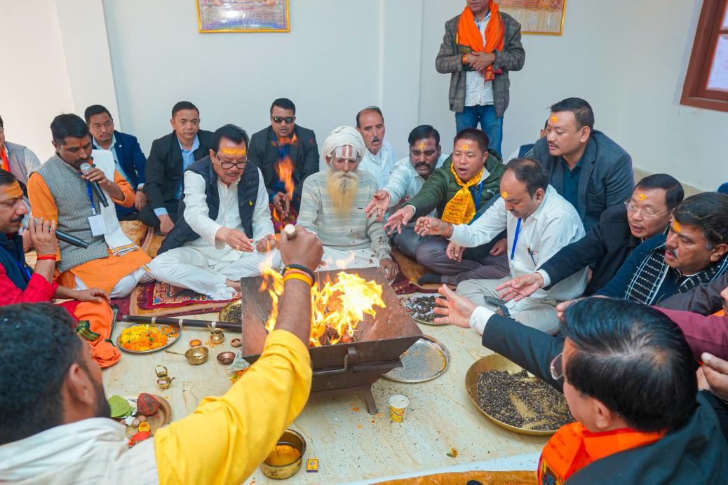

WAKRO, January 14: Deputy Chief Minister Chowna Mein inaugurated the Parshuram Kund Mela today, a revered spiritual gathering that draws pilgrims and devotees from across India and beyond. Often referred to as the "Kumbh of the Northeast," this sacred site holds immense spiritual significance, particularly during the auspicious occasion of Makar Sankranti.
In his inaugural address, DCM Chowna Mein extended Makar Sankranti greetings to the people of Arunachal Pradesh and the nation. “I warmly welcome all the pilgrims and visitors to Parshuram Kund. It is an honor to be part of this occasion of faith, unity, and devotion,” he stated.
Participating in the Havan Puja led by revered Sadhus, he sought blessings for peace, harmony, and prosperity for Arunachal Pradesh and the country. “I prayed for the well-being and prosperity of the people of Arunachal and the entire nation,” he added.
As part of his vision to establish Parshuram Kund as a premier pilgrimage destination in the Northeast, the Deputy Chief Minister announced a ₹50 crore allocation for infrastructure development under the riverfront enhancement project. This substantial investment aims to transform the site into a world-class spiritual and cultural hub, attracting more pilgrims and boosting tourism in the region.
Highlighting the ongoing developmental efforts under the PRASAD scheme, DCM Chowna Mein emphasized the significant infrastructural advancements at Parshuram Kund. He inaugurated a newly constructed guest house to accommodate the increasing number of pilgrims and tourists, ensuring a comfortable and enriching spiritual experience.
He reaffirmed the Government of Arunachal Pradesh’s commitment to enhancing security, accommodation, food, and amenities at the site. “Our goal is to provide every pilgrim with a seamless and fulfilling experience at Parshuram Kund, prioritizing their comfort and devotion,” he remarked.
On this occasion, he distributed dress coats to the volunteers of Parshuram Kund, recognizing their dedication and service to the pilgrims. Additionally, he announced his intention to carry holy water from Parshuram Kund to the ongoing Maha Kumbh Mela in Prayagraj, symbolizing spiritual unity and cultural connectivity.
The event was attended by MLA Namsai Zingnu Namchoom, Lohit ZPC Dasula Krisikro, SPs of Namsai & Lohit Districts, ADCs of Chongkham & Wakro, HoDs, and other public leaders. This year’s Mela witnessed a remarkable surge in devotees, with the organizing committee reporting a twofold increase in attendance compared to previous years.
The Parshuram Kund Mela stands as a testament to Arunachal Pradesh’s rich spiritual and cultural heritage, fostering unity and tourism while bringing people together in devotion and celebration.
