GOVERNOR’S SECRETARIAT
ARUNACHAL PRADESH
ITANAGAR

Press Communiqué

Dated Jan 14th, 2025

Chakat Aboh Provides Relief Materials to
Chinhan Fire Victims

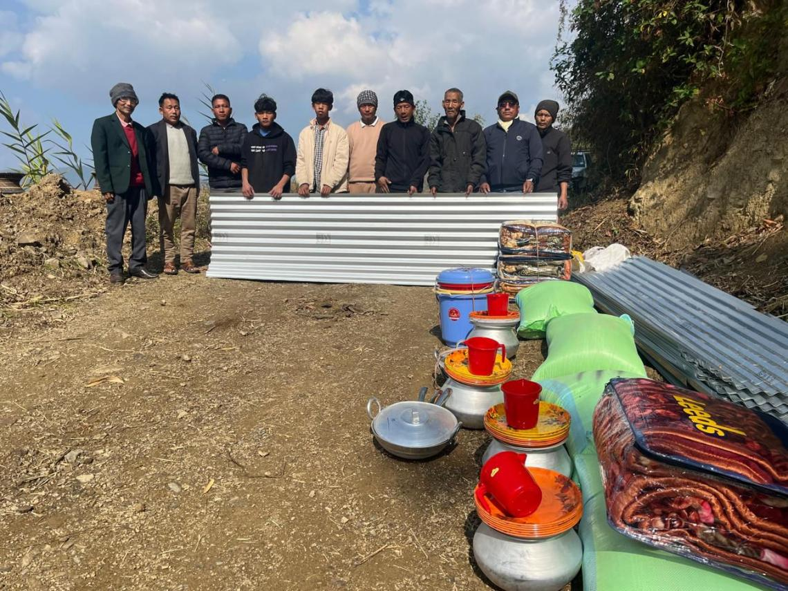

Chinhan, January 14, 2025: On behalf of Hon’ble Khonsa West MLA and Adviser to HM (State Transport), Smti Chakat Aboh, a team led by public leader Shri Riawang Kamhua and Shri Longlang Aboh distributed essential relief materials to families affected by the recent fire incident in Chinhan village, Lazu Circle. The devastating fire, which broke out at midnight on January 10, 2025, completely destroyed four houses, reducing them to ashes.
In a telephonic message, Smti Chakat Aboh urged residents of hilly and fire-prone areas to ensure sufficient spacing between houses during construction to minimize fire hazards. She expressed particular concern over the 56-Khonsa West (ST) Assembly constituency, which has been witnessing recurring fire incidents every dry winter season.
The relief assistance included 25 pieces of CGI sheets along with other essential supplies for each of the four affected families, providing much-needed support in their time of distress.

