GOVERNOR’S SECRETARIAT
ARUNACHAL PRADESH
ITANAGAR

Press Communiqué

Dated Jan 14th, 2025

Spear Corps Gunners Commemorate Armed Forces Veterans Day 2025

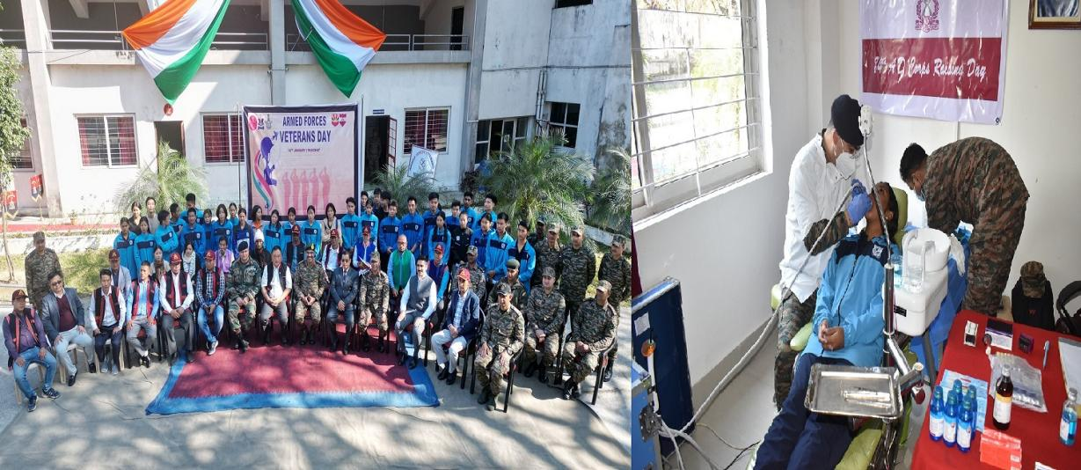

PASIGHAT, January 14: The Spear Corps Gunners commemorated Armed Forces Veterans Day 2025 at the Veterans Suvidha Kendra in Pasighat, witnessing enthusiastic participation from 20 veterans of Pasighat and 40 students from Rashtriya Raksha University.
The event commenced with friendly Badminton and Table Tennis matches, where both veterans and students showcased their skills and sportsmanship. A Medical Check-up Camp was also organized, with a dedicated team of three doctors, including a Medical Specialist and a Dentist, providing health check-ups and consultations to enhance the well-being of the veterans. The participants greatly benefited from the medical assistance and expressed their heartfelt gratitude.
During the program, veterans were briefed on various welfare schemes designed for their benefit. Additionally, they were educated on precautions against rising cyber and financial frauds targeting veterans, along with awareness about the outbreak of the HMPV virus. The event was graced by the Deputy Commissioner (DC) and Superintendent of Police (SP) of Pasighat, who shared their valuable insights with the attendees.
As a token of appreciation, all participating veterans were presented with Certificates of Appreciation and Mementos to commemorate the occasion. The Station Commander of Sigar Military Station, along with other civil dignitaries, interacted with the veterans, acknowledging their distinguished service and sacrifices for the nation. Winners of the friendly sports activities were awarded prizes to encourage their continued participation in sports.
The event reaffirmed the Armed Forces' commitment to the welfare and well-being of veterans. The enthusiastic participation of the veterans and the interaction between students and ex-servicemen served as a great motivation for the younger generation to consider a future in the Indian Armed Forces.
