GOVERNOR’S SECRETARIAT
ARUNACHAL PRADESH
ITANAGAR

Press Communiqué
Dated Jan 13th, 2024

Indian Army Celebrates Armed Forces Veterans Day to culminate the Siang Open Volleyball Tournament at Vibrant Village Tuting
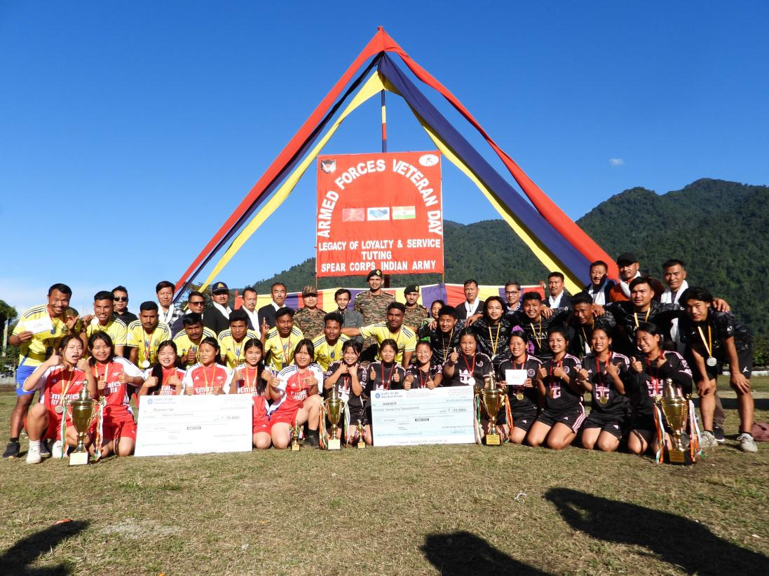

Tuting Village, January 14, 2025: In a heartfelt celebration of Armed Forces Veterans Day, the Indian Army extended its deepest gratitude to the cherished veterans of the force in a special event held at Tuting village. The occasion was marked by meaningful interactions between veterans and the children of Tuting, fostering a bridge of inspiration and shared stories that honour their rich legacy of service and sacrifice.
Highlighting the day's events was a spirited Finals of Siang Open Volleyball Tournament that engaged both the local community in a dynamic display of sportsmanship and camaraderie. The Jidu girls' team emerged victorious in the women's category, demonstrating exceptional skill and teamwork to lift the coveted trophy. In the men's category, Nine Star (Gelling) claimed the championship, showcasing remarkable talent and enthusiasm that captured the spirit of the day.
The tournament served not only as a tribute to the veterans but also as an opportunity to strengthen community bonds and inspire the younger generation through the values embodied by the Armed Forces. The veterans' interactions with the children provided invaluable guidance and insights, reinforcing the importance of service, dedication, and national pride.
During the ceremony, the army officials acknowledged the veterans' contributions and sacrifices, underscoring their pivotal role in safeguarding the nation. The event emphasized the Indian Army's ongoing commitment to honor and support its veterans, ensuring their legacy continue to inspire future generations.
The celebration in Tuting village was met with great enthusiasm and reverence, highlighting the enduring respect and gratitude the Indian Army holds for its veterans. Events like these reaffirm the strong ties between the Armed Forces and the communities they serve, celebrating heritage and unity as the nation looks to a future built on the sacrifices of its past.
