GOVERNOR’S SECRETARIAT
ARUNACHAL PRADESH
ITANAGAR

Press Communiqué
Dated Jan 13th, 2024

Deputy Chief Minister’s address to the DCs in the first day of the DC’s Conference
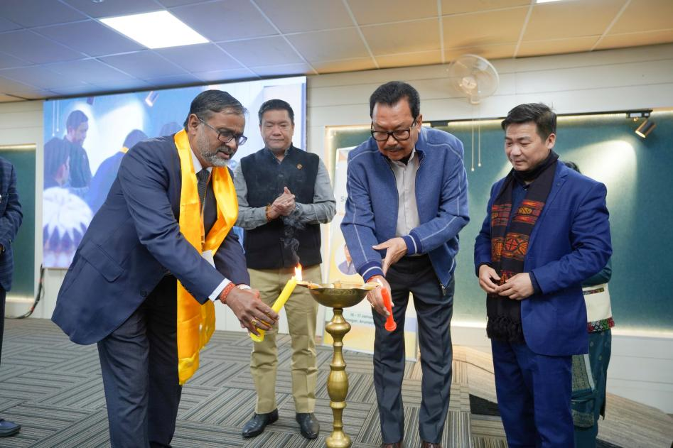

Itanagar, January 13: The Deputy Commissioners’ (DCs) Conference, themed ‘Sashakt Arunachal’, was convened under the leadership of Chief Minister Pema Khandu to align governance strategies and strengthen district-level administration. The conference served as a platform for senior officers and DCs to discuss governance challenges, share best practices, and chart a roadmap for achieving the vision of an empowered and developed Arunachal Pradesh. The emphasis was on fostering collaboration between state and district authorities to drive impactful, citizen-centric development initiatives.
Addressing the first day of the DC’s conference in the inaugural program, Deputy Chief Minister Chowna Mein congratulated the Chief Minister and his team of Officers for successfully organizing the event and encouraged the DCs to participate actively, leaving no question unanswered. Drawing inspiration from a story during Abraham Lincoln’s time, he likened the conference to "sharpening the axe," emphasizing the importance of aligning focus and efforts to propel the state’s development forward.
Reflecting on the progress made under the Double-Engine Government over the past eight years, Mein highlighted Arunachal Pradesh’s improvement in Sustainable Development Goals (SDGs), with its overall score increasing from 60 to 65. Significant strides have been made in areas such as Zero Hunger, Quality Education, Gender Equality, and Climate Action. However, he stressed the need for a saturation approach to achieve all SDG targets.
The Deputy Chief Minister emphasized the pivotal role of district-level governance in delivering impactful solutions in education, healthcare, infrastructure, and livelihoods. He also underscored the importance of citizen-centric initiatives such as Sarkar Aapke Dwar and Seva Aapke Dwar, which have already benefited around 15 lakh people. He introduced the upcoming Arun Parivar Patra initiative as a step toward ensuring inclusivity and transparency in service delivery, in line with the government’s commitment to Antodaya.
In his address, Mein urged the DCs to focus on the effective implementation of government schemes, particularly in agriculture, tourism, and youth and women empowerment. He highlighted the importance of leveraging Arunachal’s hydropower potential and raising awareness among local communities about the inclusive benefits of such projects.
Mein further emphasized the government’s ambitious plans for youth empowerment under the ‘Year of the Youth’ and the targeted goal of financially empowering 21,000 women as ‘Lakh Pati Didis’ through self-help groups. He reiterated the need for active collaboration between district and state authorities to fulfill the aspirations of Arunachal’s citizens and achieve the vision of a ‘Viksit Arunachal.’
In his concluding remarks at the Deputy Commissioners’ Conference, he emphasized the importance of adopting a strategic approach to tourism promotion in Arunachal Pradesh. He highlighted that each region of the state has its unique cultural heritage and traditions that can be leveraged to attract visitors, even if they lack the natural allure of more prominent destinations like Mechukha and Anini.

He stressed the need for a targeted tourism policy that taps into the distinct strengths of each area, showcasing its cultural identity and indigenous offerings. Such an approach, he stated, would not only boost tourism but also empower local communities and create sustainable opportunities in sectors like handloom, handicrafts, and other local industries.
He urged district authorities to focus on preserving cultural heritage while promoting tourism inclusively, ensuring that the benefits reach all corners of Arunachal Pradesh.
He stressed on formulating a strict regulations to avoid littering of river, to come up with bio medical waste disposal to make our towns and villages clean & tidy in every region.

