GOVERNOR’S SECRETARIAT
ARUNACHAL PRADESH
ITANAGAR

Press Communiqué

Dated Jan 12th, 2025

Deputy Chief Minister Inaugurates Key Infrastructure Projects in Lohit District, Strengthening Connectivity, Tourism, and Cultural Heritage

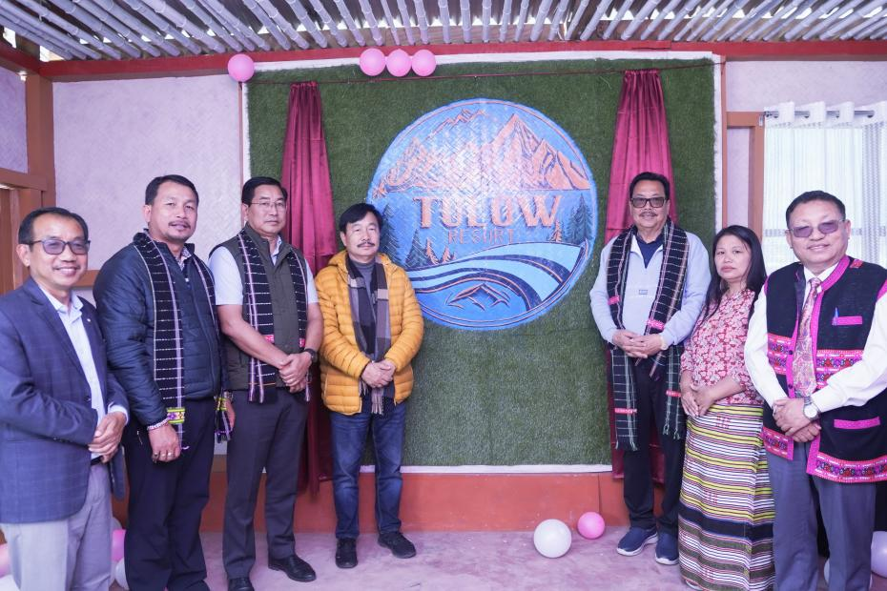

Wakro, January 12, 2025: Deputy Chief Minister Chowna Mein inaugurated multiple infrastructure projects in Lohit District, aimed at enhancing connectivity, promoting tourism, and preserving the region’s cultural and natural heritage.
Coinciding with the commencement of Parshuram Kund Mela 2025, the Deputy Chief Minister inaugurated the newly constructed Guest House and Tulow Resort at Parshuram Kund. These facilities will accommodate the growing number of pilgrims and tourists, offering a blend of comfort and cultural significance. This initiative is expected to boost the local economy and strengthen the tourism industry in the region.

Enhanced Connectivity and Environmental Conservation
As part of the connectivity enhancement efforts, Mein inaugurated the Glaw Lake Road and Steel Bridge at Sena Brai, which significantly improves accessibility to Glaw Lake, a renowned trekking destination for adventure enthusiasts.
During his visit to the Kamlang Tiger Reserve, the Deputy Chief Minister was apprised by the DFO Kamlang Tiger Reserve regarding a proposal sent to designate Kamlang Tiger Reserve as a Ramsar Site—a status recognizing wetlands of international importance under the Ramsar Convention. This move underscores the government’s commitment to preserving Arunachal Pradesh’s rich biodiversity for future generations.

Strengthening Law Enforcement Infrastructure
In addition to tourism and connectivity projects, Mein inaugurated the newly constructed Wakro Police Station. He assured that the police station would be further strengthened with manpower and equipped with essential infrastructure to enhance law enforcement and public safety in the region.

Commitment to Pilgrimage and Ecotourism
Speaking to the media, Deputy Chief Minister Mein reaffirmed the government's commitment to developing Parshuram Kund into a major pilgrimage site by creating modern facilities for pilgrims and tourists. He emphasized efforts to facilitate a comfortable experience for devotees visiting the site for the holy dip.
Additionally, he announced plans to develop Glaw Lake into a premier trekking destination, ensuring that the natural vegetation and wildlife corridor of Kamlang Tiger Reserve remain undisturbed while preserving the region's rich flora and fauna.

Dignitaries Present
The Deputy Chief Minister was accompanied by:
- Member of Parliament (Arunachal East), Tapir Gao
- Advisor to the Minister of Health & Family Welfare and Commerce & Industries, Dr. Mohesh Chai
- ZPC Lohit, Dasula Krisikro
- Deputy Commissioner Lohit, K. N. Damo
- SP Thutan Jamba
- Chief Engineer (PWD), Winam Manpoong, among others.
